
Measure for a PCL Brace (Posterior Cruciate Ligament):
Patient Name…………………………………. Hospital No…………………….. NHS………………………
Measurements taken by;
(print name)………………………………. (sign)………………………….. Date: ……………………

- At the knee joint line measure circumference (cm) and width (cm).
- 15cm above the knee joint line measure thigh circumference (cm).
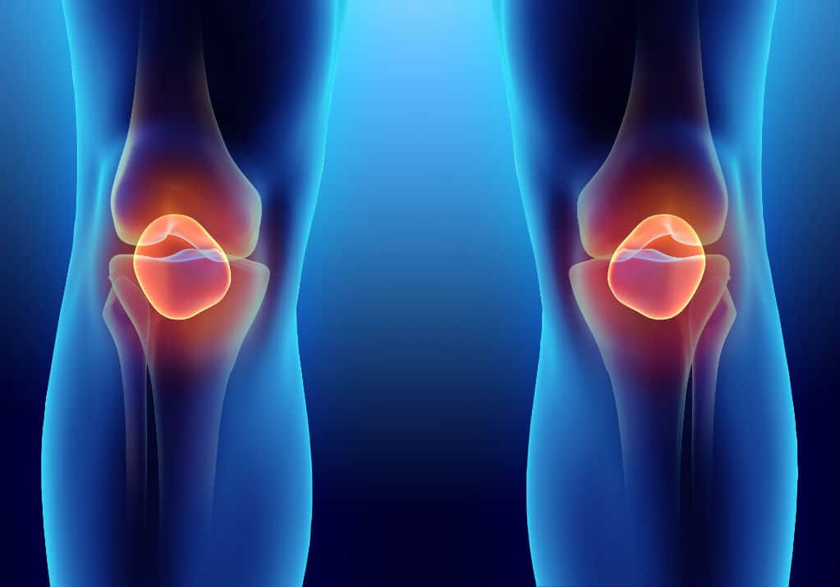
- 15cm below the knee joint line measure proximal calf circumference (cm).
1. Knee joint Line:
Circumference
& Width
15cm above knee joint line
15cm below knee joint line
2. Thigh Circumference
3. Proximal Calf Circumference

_______cm

______cm

_______cm

_______cm

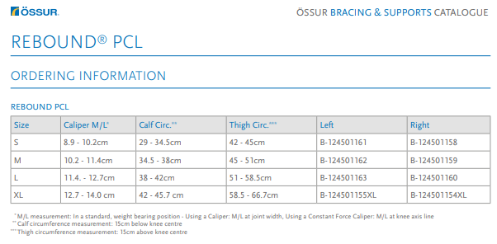
Orthotist Feedback:
Was the form completed correctly? Y/N Comments:
Orthotist Name ………………………………………….. Orthotics No. 01691 404442
4. Size guide (Orthotics to decide final prescription)

