|  |  |
| --- | --- |
|  |  |



**Strategic Plan Document for 2018-23**

**The Robert Jones and Agnes Hunt**

**Orthopaedic Hospital**

**NHS Foundation Trust**

**February 2018**

Contents

2 Executive Summary 4

2.1 Mission 4

2.2 Vision 4

2.3 Strategy 4

2.4 Enabling Strategies 5

2.5 Corporate Objectives 5

2.6 Summary of our strategy 6

3 Strategic Options 7

3.1 Do Nothing Option 7

3.2 Preferred Option 7

3.2.1 Why integrating local MSK services? 7

3.2.2 What is operational excellence in practice? 8

3.2.3 Focusing on Specialist Orthopaedic Services? 9

3.2.4 How does culture and leadership support? 10

4 Risk to sustainability and strategic options 12

4.1 Key Risks 12

5 Capacity Analysis 14

5.1 Theatres 14

5.2 Beds and Bed Equivalents 15

5.3 Outpatient Clinics 16

5.4 Workforce 16

5.4.1 Medical 17

5.4.2 Nursing 17

5.4.3 Allied Health Professionals 18

5.4.4 Other Scientific, Therapeutic and Technical staff 19

5.4.5 Admin and Clerical 19

6 SWOT Analysis 20

7 Funding Analysis (As per 2017/18 submitted plan, will be updated annually) 21

7.1 Capital programme 22

7.2 Productivity, Efficiency and Cost Improvement Plans (CIPS) 23

7.3 Key Financial Risks 24

8 Governance 26

9 Consultation & Dependencies 28

10 Summary 29

11 APPENDICES 30

11.1 Market analysis and context 31

11.1.1 Shropshire 31

11.1.2 Telford & Wrekin 35

11.1.3 North Wales 36

11.1.4 Powys 38

11.2 Competitor Analysis 40

11.2.1 Direct Competitors 40

11.2.2 Indirect Competitors 43

11.3 Impact on key service lines 45

11.3.1 Orthopaedics 45

11.3.2 Rheumatology 46

11.3.3 Chronic Pain Management 47

11.3.4 Geriatric Medicine 48

11.3.5 Paediatrics 48

11.3.6 Spinal Injuries 49

11.3.7 Orthotics 49

11.3.8 Orthotics Research Locomotor Assessment Unit 50

11.3.9 Sports Injuries 51

11.3.10 Bone Tumour 51

11.3.11 Therapies 51

11.3.12 Radiology 52

11.3.13 Pathology 52

11.3.14 Pharmacy 52

# Executive Summary

The Trust Board has confirmed its strategy to deliver a sustainable organisation - clinically, operationally and financially over the next five years.

To support this it has formulated a strategy which has been based on a detailed and integrated review of a number of areas, internally and externally –

* **Market Analysis & Context** – the Trust has reviewed the healthcare needs of the local populations it serves, and the changing demography. It has identified that the population is growing, particularly in the over 65’s.
* **Competitor Analysis** – our immediate main local competitor is Shrewsbury and Telford Hospital NHS Trust, serving similar population demography.
* **Capacity Analysis** – we have reviewed all of our internal capacity, including our workforce, number of beds, inpatient theatres and outpatients, and developed our strategic plans accordingly to address the specific requirements of each.
* **Financial Analysis** – The Trust has modelled its expected income, costs, capital programme and financing, and its efficiency requirements over the next five years. It is confident that it can deliver all of these sustainably, whilst continuing to deliver safe and effective care for our patients.
* **SWOT Analysis** – We have undertaken a full strategic SWOT analysis and a comprehensive review of the risks to the organisation and the mitigating actions necessary. Again we are confident that we can counter any identified weakness or threat in the future that transpires, and make the most of our opportunities and build on our organisational strengths.
* **Service Line Review** – We have reviewed all of our key service lines, we understand the financial contribution of each, and the clinical opportunities and challenges facing them. Our long term Trust strategy is based on and has been shaped by the outputs of this review.

## Mission

Hence the core purpose and mission of our organisation is;

* Caring for Patients
* Caring for Staff
* Caring for Finances

## Vision

In doing so our vision is ‘aspiring to deliver world class patient care’, to achieve this our Trust strategy is based on adopting a future model of care where the Trust plays a key role as an integrator for MSK services and specialist orthopaedic care.

## Strategy

Delivering our vision is through the achieving our three key strategic priorities;

* *Integrated MSK services*

Working with our local healthcare and other partners to drive service re-design and integrate MSK care for the residents of Shropshire. We achieve this by delivering our ambition to become the lead MSK integrator for Shropshire.

* *Orthopaedic Specialist Services*

Providing the right services to meet the needs of our patients, either as part of clinical network or as a specialist centre in our own right.

* *Operational Excellence*

Reviewing our core services to ensure they deliver the outcomes and quality our patients deserve.

## Enabling Strategies

The three programmes of work are supported by a series of enablers;

* *Culture and leadership*

To continuously improve our performance through consistently bettering our employee experience to become an extraordinary place to work.

* *Technology*

Making best use of medical and information technology available.

* *Clinically Led*

To make ourselves the most clinically led and engaged organisation in the NHS.

* *Research, Education & Innovation*

To utilise the learning and creativity that exists within our organisation to ensure the delivery of quality outcomes, efficiency and sustainability.

* *Patient Experience*

Providing the best possible experience, getting the basics right, making sure our patients feel safe and well-cared for, that they have trust and confidence in the staff caring for them and that they receive excellent quality care in a clean and pleasant environment.

* *Quality*

Our commitment is to constantly provide the highest possible standards of compassionate care and the very best patient and staff experience. The Quality Improvement Strategy is a rallying call for every single employee, volunteer, and governor to ensure that we deliver excellent care, every time to every patient.

## Corporate Objectives

* *Delivering outstanding outcomes and patient experience*

The continued development of our site and services is important in the delivery of world class outcomes and patient experience, therefore we will actively engage with patients and carers encouraging all feedback and demonstrating genuine learning from listening.

* *Achieving outstanding patient safety*

Our aim is to create a culture of continuous improvement and learning which is both patient centred and safety focused. Therefore we will provide healthcare which is value based, with sound evidence that our procedures are most likely to benefit patients and not lead to harm, we call this ‘value based procedures’.

* *Delivering timely access to patient care*

Through strengthening our accountability and the responsiveness of our services by being patient centred we will deliver timely access to patient care. This will be delivered through expanding our transparency and use of operational information in decision making. Together with strengthening our collaboration with partners to create sustainable clinical services.

* *Being an extraordinary place to work*

Developing effective leadership and an open culture is key, therefor we will look to;

* + To improve staff engagement and motivation to enhance staff and patient experience.
  + To develop compassionate and effective leadership.
  + To support staff to maintain their physical and mental health and wellbeing.
  + To support the development of a skilled, flexible workforce able to adapt to new treatments, working practices and care pathways.
  + To realise the benefits of a diverse workforce.
* *Spending our money wisely*

People represent a huge investment for RJAH, we regard our workforce as a huge asset to the NHS, one which should be harnessed for its creativity and productivity rather than controlled. We have a wealth of talent in RJAH, and will engage this talent to solve efficiency and productivity issues we face. This ensures we see our people as the solution.

We will aim to strengthen our accountability of staff, improving the financial control by developing our clinical leadership creating clarity between bringing together responsibility for clinical decisions with the financial consequences of those decisions. Whilst simultaneously eliminating issues that reduce the ability of our staff to do their job in an efficient manner.

* *Delivering regulatory requirements*

To retain autonomous working we must be consistent in our compliance with our regulator NHS Improvement and the Care Quality Commission, through horizon scanning and preparation for new directives and challenges. Ensuring as an organisation we operate to higher standards of safety and achieve outstanding results through smarter use of our resources.

## Summary of our strategy

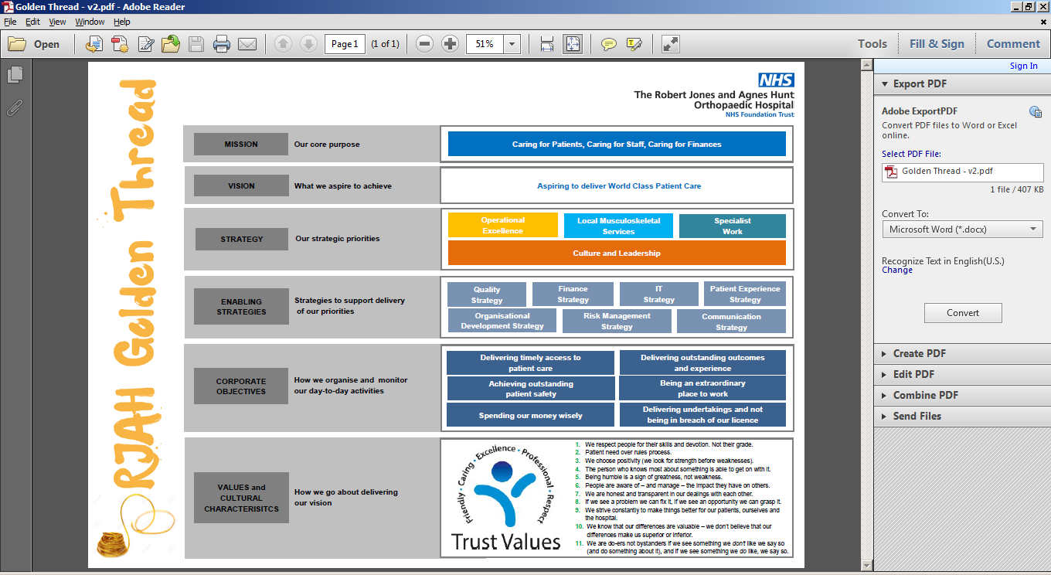

# Strategic Options

## Do Nothing Option

Continuing to provide an inpatient based model of care in a wholly hospital bed setting focused purely on surgical intervention is strategically unsustainable in the long term due to the increasing demographic, limited health economy funding and a greater emphasis on conservative management.

The cost of this model is unaffordable to our commissioners, and the Trust does not have sufficient physical capacity in its current configuration to deliver it. Therefore a new model is proposed below.

## Preferred Option

Our preferred option is to continue to ***grow*** both in the orthopaedic surgical care activity we provide whilst also adopting a future model of care where the Trust plays a key role as the local system integrator for musculoskeletal services.

This is based on the interpretation of strategy as follows;

“Strategy is the direction and scope of an organisation over the long-term: which achieves advantage for the organisation through its configuration of resources within a challenging environment, to meet the needs of markets and to fulfil stakeholder expectations”.

Our vision is aspiring to deliver world class patient care through being the leading centre for high quality sustainable orthopaedic and related care.

Hence the development of our organisational strategy across four strategic themes;

* Integrating local MSK services.
* Operational excellence.
* Specialist orthopaedic services.
* Culture and leadership.

### Why integrating local MSK services?

The analysis for this element of the strategy has shown us that one of our main commissioners has an aim of reducing the spend for the county in orthopaedic care, therefore there is an impetus as a specialist in MSK and orthopaedic care for RJAH to be fully involved and leading the care of our patients with MSK related conditions.

The data tells us;

* Shropshire CCG financial position with 2016/17 deficit for Shropshire CCG was £25.98 million, anticipating c.£8m savings from orthopaedic care.
* Shropshire demography changes of 8.5% growth in population from 2015 to 2031, with 65 to 84 year age group projected to increase by 34,500 people by 2031.
* Oxford Knee Score 2016 of 20.98 PROMS adjusted health gain, national median is 16.76.
* Oxford Hip score 2016 of 24.11 PROMS adjusted health gain, national median is 21.73.

As a Trust we have the expertise, knowledge and know-how to improve care pathways for patients to ensure that patients are seen at the right time, in the right place by the right person at all times.

This will enable the Trust to manage the inevitable risk from change balancing the change in clinical practice and subsequent changes in demand for surgery whilst recognising a likely status quo in surgical activity due to the changing demographics illustrated within our analysis, effectively planning and managing demand within the system well. Whilst also underwriting the quality of care in the system for MSK conditions, ensuring a longer term partnership is formed to benefit of our citizens.

The Trust outcomes and joint registry data informs us that our patients receive great outcomes, this knowledge enables us to use this expertise to provide care with similar outcomes across the whole patient journey.

The Trust will focus initially on our main local commissioner of Shropshire, integrating local MSK services will be just as important within Telford & Wrekin and our Welsh commissioners where there are different demographic factors, but wider workforce and estate implications. This will mean a move to a RJAH@, operating out of alternative locations than the current provision.

Hence our definition of MSK services is as follows;

“Musculoskeletal services delivered by RJAH ensure that patients are cared for, and when possible rehabilitated, where they have a condition that affects the joints, bones, spine and muscles that can be characterised by pain, stiffness and limitation of movement.

This can include all forms of arthritis, back pain, osteoporosis, results of injuries or infection, soft tissue wounds and long term disabilities together with autoimmune diseases that limit everyday activities, together with subsequent rehabilitation.

Our services cover the complete MSK pathway (physical, mental and social wellbeing) of prevention, assessment, self-care, intervention, treatment and rehabilitation to enable patient independence and an active lifestyle.

This is an integration of different MSK specialities and professional groups.”

This aligns with the national movement towards integrated care services and changing models of financing relating to accountable care, enabling RJAH to grasp opportunities to grow whilst simultaneously protecting our current services and realising prospects of savings, sharing best practice and establishing more collaborative relationships.

### What is operational excellence in practice?

Our strategy is predicated on a requirement to grow based on the following data;

* Demographic modelling, local and national showing an ageing population growth and therefore the subsequent activity within MSK and orthopaedics.
* Growing waiting lists with competitors and further afield.
* National movement towards hot and cold sites, together with winter capacity impacts.
* Activity levels carried out with private providers.
* GIRFT recommendations.

Hence operational excellence is about delivering excellent, efficient and effective care ourselves through our own processes, reflecting our desire to have a clear view of our capability as we make significant improvements to our services.

We must ensure the most efficient and effective use of our current resources ensuring our capacity across all continuously matches up. As we continuously improve our theatre utilisation, there will be a requirement to grow our bed base and the services that support this, monitoring our step change points. Maximising theatre throughput across all available time will be key to delivery of our growth strategy for marginal cost benefit.

Hence, our approach will be centred on a detailed review of all our services over the short to medium term. We have designed a standardised methodology for reviewing the specialties based on current published literature, research and reports.

These reviews will become live documents updated and refreshed periodically as specialty changes are instigated and to inform not only short-term business planning but also the strategic direction of the organisation.

Simultaneously we have initiated a site strategy review to understand and make best use of the capacity and space available to us when considering bed requirements and lean flow methods for efficient patient flow.

Throughout we will seek to understand and respond better to the needs of our patients through our patient experience strategy, and reviewing our complaints processes.

The question outstanding within operational excellence is the level of mix of work between complex and routine. The analysis through GIRFT shows the benefits of centralising high volumes of complex work giving both better patient outcomes and more cost effective. It is also recognised as a benefit in the recruitment and retention of our workforce through the completion of stimulating work whilst improving the efficiency of more routine work due to greater expertise and knowledge. However, the NHS pricing models have yet to be amended to reflect this national programme of evidence, resulting in complex work not producing financial margins. Therefore in the short to medium term the Trust needs to ensure consistent monitoring and balance the routine/complex mix within a set of tight parameters close to current levels, but also be agile enough to respond once pricing models change.

The Trust has appointed a private patient manager who commences in 2018/19, this will both ensure efficient processes, dovetailed with our NHS activity. This position is predicated upon growing the Trust’s private patient market share. As indicated waiting list growth in orthopaedics is known from our analysis, history indicates that this indicator often is paired with an increase in private patient work. Hence, the next 12 months will enable the Trust to review these assumptions and model step activity changes that would require investment in facilities. The Trust recognises that within the next five years, following a private patient growth strategy will require an update in facilities; our modelling will ascertain whether the increased activity will self-fund such developments or whether a partner will be required.

Our private patient review will scope out the international market, as we know that other NHS partners have grown their private patient market share through the establishment of joint venture with private providers to attract international private patients. The limitation for The Trust is its geographical location, making it less attractive to international patients, due to the lack of city location and the proximity to the facilities provided within a city.

### Focusing on Specialist Orthopaedic Services?

The Trust has a number of specialist services, namely;

* Midland Centre for Spinal Injuries
* Bone Tumour Service
* Veteran’s services
* Paediatric services
* Orthotics Research Locomotor Assessment Unit

The Trust is continuing development of the Midland Centre for Spinal Injuries (MCSI), recognising the changing demographics in this specialism and also the national shortage of bed capacity available. Much focus is being placed upon the patient experience within this service with the development of Horatio’s Garden and the need for better gym facilities in the near future. As we move forward there is an expectation of greater focus on our patient pathways and development.

Through the infrastructure investment placed within our national bone tumour unit recently, our focus now moves to patient outcomes and the use of this data in our care model and any potential future expansion of service, whilst looking to ensure alignment with operational excellence for continuous improvement in the efficiency of our services.

The Trust has already agreed a strategic case outline for the continued development and expansion of our Veterans service, which is now a founding member of the Veterans Covenant Hospital Alliance with an approved kite mark. The Trust is already seeing the step change in activity growth for this service as predicated within the case (graph below) and therefore expanding its workforce to support both this service and our wider orthopaedic work.

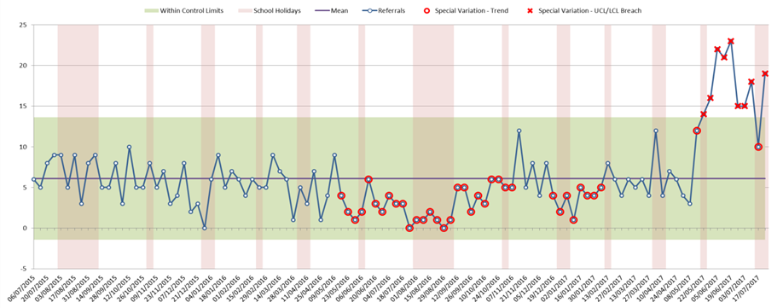

As we move into 2018/19 we intend to focus on the longer term future of our paediatric services with recent changes in the West Midlands locality and the ever increasing bar of quality standards. Reviewing both our surgical and inter-linked rehabilitation services such as ORLAU to ensure an agreed long term direction.

Simultaneously the Trust will ensure it remains fully sited on NHS England specialized services intentions as it directly commissions 143 specialised services, with specialised services provided from relatively few specialist centres. The services are commissioned nationally and account for approximately 10 per cent of the NHS budget. NHS England foresees a concentration of expertise in some 15 to 30 centres for most aspects of specialised care.

As highlighted within operational excellence, GIRFT recommends the centralisation of more complex procedures in one centre. The specialist nature of our Trust therefore attracts our workforce which in turn enables our clinicians to complete the more complex procedures, ensuring that our routine operations are carried out in an efficient manner. Hence, our brand and attraction of being a specialist centre needs to continue.

Being one of few specialist orthopaedic hospitals does come with a risk, of the sole speciality focus and therefore both the risk in waiting list delivery together with tariff. As we move forwards the Trust will review if it would be beneficial to add another specialty to our offerings that fits with our modus operandi of being able to operate in only electives setting.

### How does culture and leadership support?

Healthy organisations dramatically outperform their peers, the proof is strong, the top quartile of publicly traded companies in McKinsey’s Organisational Health Index deliver roughly three times the returns than those at the bottom quartile.

It’s been found that organisations that work on their health, not only achieve measurable improvements in their organisational well-being but demonstrate tangible performance gains in as little as 6 to 12 months, holding true for organisations across sectors and regions, as well as different contexts from turnarounds to good-to-great initiatives.

Hence, managing our organisational health through our culture and leadership as rigorously as we do our financial sustainability is key to our delivery of this strategy.

This is more than just culture or employee engagement but our ability to align effectively around our common vision of ‘aspiring to provide world class care’ and renew ourselves through innovation and creative thinking.

This will be ‘how our organisation is run, no matter who is at the helm and what waves rock us’.

# Risk to sustainability and strategic options

## Key Risks

As a specialist orthopaedic trust, the risks facing RJAH are both operational (in-year) and strategic (3-5 years) and as such the risks identified below are framed on this basis. We will monitor both the operational and the strategic risks through our robust governance framework.

|  |  |
| --- | --- |
| **Key Risk** | **Actions by the Trust** |
| **Operational Delivery**   * Changing commissioning landscape (annual report) * Compliance target delivery * Number of cancellations * Wales – cross border issues and management of demand * IM&T - maintaining effective informatics systems & services | * Continue integrated working with local partners * Enhance our focus on building an internal performance assurance culture through new framework * Ensure sufficient escalation capacity * Board development programme * Early identification of variances * Robust monitoring, performance review, and action plans where required * IM&T on BAF and Trust reviewing PAS replacement |
| **Clinical Sustainability**   * Failure to shift the dial on staff engagement. (annual report) * Medical staffing numbers to sustain rotas * Junior doctor’s rotas and availability * Skilled workforce availability, sustainability and flexibility (incl impact of demographic changes). (annual report) * Ability to meet NHS England’s specialised service specifications and relevant public health functions * Catchment and demographics * Patient volume/demand | * Partnership working with other NHS acute providers including joint rotas and clinical collaboration * Close liaison with Deanery * Undertake detailed service reviews * Develop integrated planning arrangements across the local health economy |
| **Financial Sustainability**   * MSK service review fails to deliver expected benefits(annual report) * Impact of demographic changes (older, population) not reflected in resources * In ability to take out cost due to fixed overheads * CIP / efficiency delivery (annual report) * Long term contractual & commissioning intentions – cross border & geo/political systems * External tendering of services * Lack of clarity on specialised commissioning intentions, expectation of increasing provider requirements and restrictions * Competition and costly tendering processes * Medical pay * Impact of IM&T requirements | * Finance, Investment & Planning Committee (exec, non-exec & senior operational/clinical managers) * Greater focus on benefits realisation * Refreshed medium term financial plan and ensure effective cost efficiency strategy * Integrated service, quality, workforce & capital planning * On-going engagement with Betsi Cadwaladr UHB re their commissioning intentions * Positive contractual agreement * Greater understanding of service line reporting in context of system wide Long Term Financial Model (LTFM) |
| **Quality, Safety & Patient Experience**   * Failure to deliver CQC rating. (annual report) * Inadequate or unsuccessful implementation from learning from incidents. (annual report) * Delivery of CQUIN, quality measures * Clinical engagement & leadership * Culture and morale * Resistance and capacity to deliver change * Communication challenges. * System-wide quality improvement strategy * Access to quality data & information * Trust values & behaviours * Information Governance risks | * Quality & Safety Experience Committee established and chaired by a non-executive director * Development of the Quality Improvement Strategy * Refreshed Risk Management processes * Refreshed Leadership Development & Staff Engagement & Experience Programme * Clinical leadership development programme * Positive values and behaviours are encouraged * Speak out safely adopted * Communications team enhanced * Refreshed IM&T governance structures and arrangements |

# Capacity Analysis

The Trust has considered each area of its capacity in turn –

## Theatres

2016/17 saw the opening of the Trust’s new theatre development, this encompassed four theatres, a replacement HDU with extended admission and recovery facilities. This was based upon original modelling indicating the requirement for a ten theatre model with flexibility for future expansion together with increased admission and recovery facilities for increased day surgery patients that are open between 7am and 10pm improving our admission on day of surgery and reducing pressure on bed requirements.

The Menzies Unit, a standalone modular building housing two operating theatres and a procedures room, originally on lease until September 2016 has been extended with a 10 year contract with a five year break clause at a significantly reduced rate. During 2016/17 phase one will open one of the theatres to provide an additional 10 sessions per week. The opening of the remaining theatres will be subject to assessment of future demand with further opening in 2017/18.

RJAH recognise that there is a £0.3m contribution from every one per cent improvement in utilisation of our theatre minutes, which in 2016/17 was 68% utilisation. Previously this opportunity was hindered by;

* Historical culture/organisation memory.
* Scheduling completed four to six weeks in advance linked to annual leave notice.
* Surgeons having ability to cancel out of job plan sessions at any time.
* High proportion of core surgical activity reliant on voluntary work and majority through Oswestry Orthopaedics LLP.

The Trust approached the LLP negotiations for 2017/18 over a three month negotiation period, handled sensitively, resulting in a radically improved contract including;

* Equitable process for LLP and non-LLP members.
* Three months’ notice to annual leave to secure access to priority allocation.
* Guaranteed volumes including growth to repatriate private sector work.
* Penalties for cancellation.
* Strong relationships built.

Subsequently RJAH have put in place a scheduling hub illustrated below;

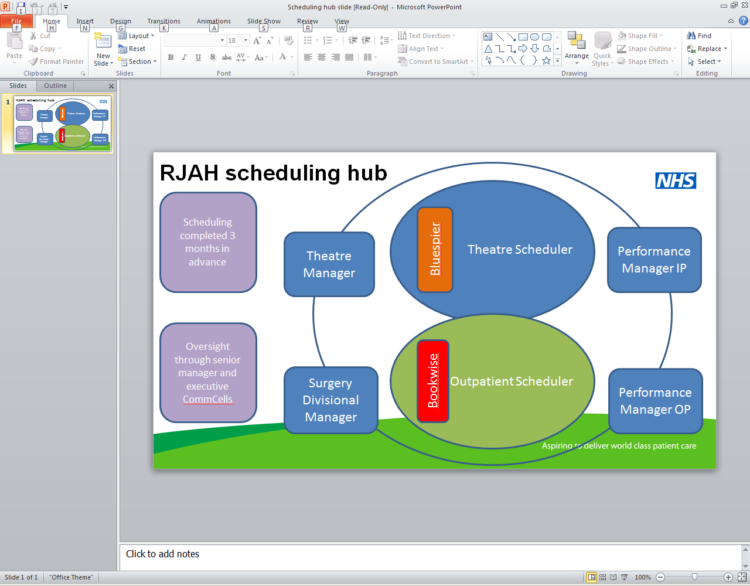

The above has allowed for the following benefits realisation which we will build upon within the framework of operational excellence for continuous improvement over the next five years;

1. Predictability of used sessions
   * 7% increase in the number of sessions used November year to date versus prior year.
   * Increase to 70% of operating hours over the same period – 319 hours to 330 hours per week.
2. Focus on productivity within sessions
   * Agreeing productivity improvements with consultants on an individual basis.
   * Total package of care model proposals in progress.
3. Ability to secure increased consultant availability on a flexible basis
   * 300 outsourced procedures repatriated.
   * 230 transfers from Wales to support waiting time reductions.
4. Cancellation reductions
   * Improved anaesthetics, theatre staff and kit scheduling through forward look.

The next steps are;

* Further roll out of forward scheduling e.g. across anaesthetics, theatre staffing and beds.
* Total package of care models for out of job plan working.
* Consideration of productivity based contracts.
* Utilising operational excellence to deliver further innovations to improve productivity.

## Beds and Bed Equivalents

The Trust is working to deliver a strategy which provides sufficient beds and staff to deliver the healthcare needs for the demand levels for orthopaedic services from our commissioners, from an estate which promotes the effective use of that capacity with eight inpatient wards including a private patient ward in addition the Trust has a spinal injuries unit. However, changing demographic and financial circumstances, and the intentions of commissioners, mean that staffing and bed numbers continue the need to become more flexible in the future.

To ensure a flexible bed base and maintain stability in bed occupancy at 85% regular bed modelling reviews are taking place.

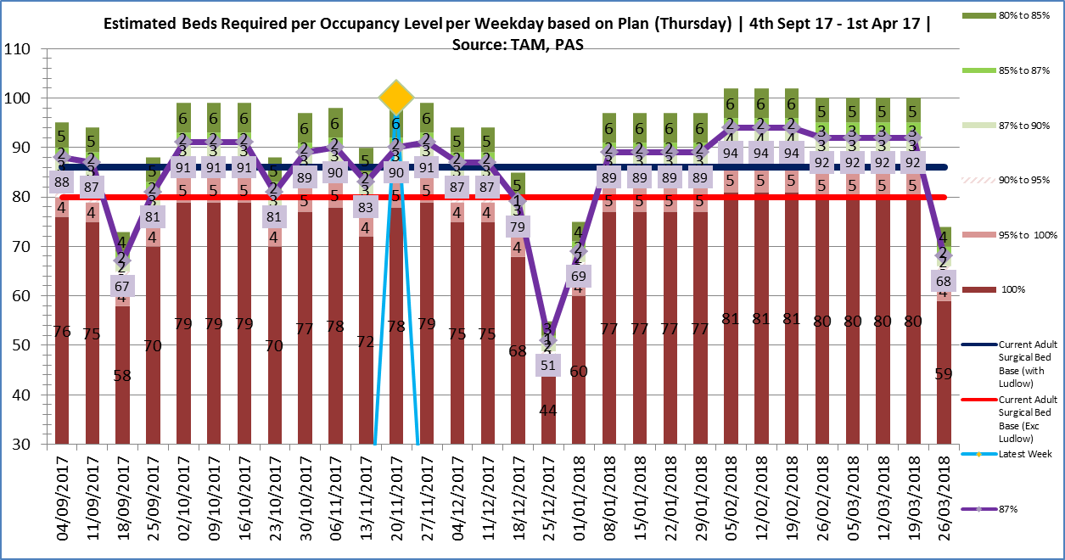

For current activity and variation levels, due to increased referral rates received from Shropshire CCG in the first two quarters of 2016/17, the Trust has a requirement for an additional eight beds which is anticipated to continue into 2017/18 which will be managed through the fixed flexible opening of our Kenyon ward. Further work will continue to ensure we maximise the benefits of our new Baschurch unit in improving patient flow which should offset further bed pressures, together with driving a reduction in variation through a continued focus upon job planning, distribution of case mix and streamlined booking to include variables such as length of stay, together with a focus on discharge times.

## Outpatient Clinics

The Trust has sufficient outpatient capacity to meet its current needs, albeit there is recognition of bottlenecks at particularly periods. Our activity growth projections, due to changing patient pathways, increased demand management and the implementation of Shropshire Orthopaedic Outreach Service anticipate a change in outpatient activity over the coming years and therefore the Trust have implemented a outpatient capacity and demand model that incorporates the use of the estate to monitor such changes and enable greater diluted planning in the coming years.

Hence, at this time only a moderate increase in demand over the next five years in anticipated, therefore with efficiency improvements and improving our new to follow-up ratio we will contain this growth within our current capacity. In addition the Trust is exploring options to move some clinics into the community to improve access and convenience for patients.

## Workforce

The Trust needs to resolve our capacity and demand, currently too many of our operations are delivered outside of our core plan. This is through out of job plan (OJP) arrangements (31% theatres and 19% outpatients 2015/16) and outsourcing (sending patients to private hospitals for their surgery). The Trust recognises that when we do this we reduce the financial contribution (the margin) that this work affords.

The Trust is currently working through a programme with a phased approach, as highlighted above, reviewing our OJP capacity as follows;

* Phase one; agree volumes of OJP activity in advance and contract on this basis.
* Phase two; agree a series of productivity based improvements to our OJP working arrangements.
* Phase three; agree a reward system based upon performance linked to our refreshed Trust strategy, productivity, values and behaviours.

The Trust completed a capacity and demand review which has indicated the requirement to increase consultant capacity in particular sub-specialties. Recruitment commenced in 2016/17 to a number of new consultant posts creating the additional capacity required for sustainable delivery in 2017/18. Through recruitment the Trust looks to achieve;

* To sustainably achieve the 92% threshold.
* Respond to increased levels of demand.
* Increase flexibility in sub-specialties to respond to peaks of demand.
* Create additional core capacity.
* To make a positive contribution to sub-specialty service lines.
* To provide effective consultant succession planning.
* Work towards a maximum of 20% of core activity undertaken on a flexible basis as OJP.

As highlighted above the opening of the Menzies Unit and Kenyon ward instigates the requirement to substantively recruit in nursing and theatre staffing in response to expanding our clinical workforce and increased activity levels with an agreed baseline activity from our main local commissioner. The Trust have put in place a monitoring tool in regards to activity levels to ensure core resource capacity remains in line going forwards and that OJP working arrangements are only utilised for flexibility purposes.

Over the next year, we will look to further collaborate with partners such as Shropshire Clinical Commissioning Group (CCG), Shropshire Community Trust (Shropcom), South Staffordshire and Shropshire Mental Health Foundation Trust (SSSFT), Shropshire GP Practices and the Local Authorities. We aim to produce more sophisticated workforce plans, across the wider health economy where possible, so that we are able to respond better to changes in our community, in terms of supply and demand.

In particular, this may include:

* facilitating secondary care clinicians working with primary care outside of the hospital setting;
* the use of extended scope practitioners to support primary care

We continue to reshape and restructure the organisation around patient pathways and carry out a number of skill mix reviews.

We will ensure the workforce is affordable, by providing sustainable, cost effective solutions to gaps in medical staffing rotas. This will be supplemented by upskilling of clinical posts, with assistant and advanced practitioners where possible.

Gaps in rotas and minimal competency in some specialties has resulted in the pay bill for locum and consultant cover, we are thinking creatively about how we address this issue in the long term.

### Medical

RJAH have been successful in the development of senior trainees through the provision of teaching for orthopaedic surgeons to consultant status with a high percentage of our former trainees now leading surgeons in hospitals all over the UK. We intend to continue with this endeavour providing protected teaching time on Friday afternoons for all deanery trainees who will take the FRCS Orth examination. We will also continue to structure consultant job plans to support medical education commitments including regular teaching and attendance and regional and national courses. Our intention is to develop pur training programmes for medical and diagnostic specialties together with introducing a RJAH medical leadership programme.

By educating and training senior ‘junior’ doctors we are developing our future clinical workforce, many of whom will become consultants.

### Nursing

Our nursing strategy is based upon delivering an effective, efficient service that seeks out the views of our patients to continually improve quality of care, underpinned by the national nursing strategy of the 6C’s: Care, Compassion, Competence, Communication, Courage and Commitment. This ensures that our nurses continue to embrace the Trust values with the professionalism and care ethics that guide their daily practice in all care settings, ensuring that patient centred care is at the heart of our practice.

Our nurses will demonstrate professional behaviour to reaffirm their role as advocates and guardians of quality care, treating people with dignity and respect, with care and compassion and with impartiality. Therefore our intention is;

* To ensure that clinical care meets and exceeds the essential required standards of quality and safety.
* Ensure that the service provides a safe, life enhancing experience for the whole family unit for the duration of their interaction with our services.
* To optimise and improve the health outcomes of all patients helping them to remain independent.
* To deliver a nursing workforce fit for the 21st Century, ensuring we have the right staff, with the right skills, in the right place.
* Delivering high quality, safe, effective and compassionate care, measuring its impact and where required ensuring improvement.
* Delivering high quality care and measuring the impact.
* Advance practice and care by participating in clinical research and audits with a particular emphasis on nursing outcomes.
* Using agreed national quality indicators to drive the process of change.
* Agree a set of nursing performance measures specific to each area that will become our “nursing dashboard” in a constant drive to improve the nursing care we deliver.

We will look to further develop the ANP and ENP development programme to provide more support for existing ANP’s and ENP’s and attract external staff, consideration needs to be given as to the revenue to support the roles as there appears to be a difficulty transferring funds from medical roles to nursing roles.

As we increase working in partnership with patient pathways with other provider organisations, further nursing issues may need to be addressed or developed.

The most important way to ensure a positive patient outcome and patient experience is with strong leadership.

### Allied Health Professionals

RJAH have established an AHP lead for the Trust, who sits within our senior leadership team and attends clinical cabinet, supporting the national movement of ‘Allied Health Professions into Action’ to;

* Understand the opportunities of the contribution of AHPs including their transformative potential and any challenges.
* To strengthen AHP leadership.

RJAH recognise our AHP workforce can support our strategic direction, particularly our MSK service aspiration, through;

* Improving the health and well-being of individuals and populations.
* Support and provide solutions to general practice to address demand.
* Support integration, addressing historical service boundaries to reduce duplication and fragmentation.
* Deliver evidence based/informed practice to address unexplained variances in service quality and efficiency.

There RJAH will support our AHPs to meet the challenges of changing care needs through;

* AHPs that can lead change.
* Further developing AHPs skills.
* Support our AHPs to evaluate, improve and evidence the impact of their contribution.
* Develop AHPs to more greatly utilise information and technology.

This is in the context of between 2012 and 2017 HEE maintained broadly the level of AHP training places to support a strong growth in the number of registered AHP’s. Since the change in undergraduate funding models physiotherapy has seen a significant increase in student numbers as well as extra training places announced in 2017. However, it is recognised that certain AHP groups, the undergraduate courses are struggling to be filled such as orthotics and podiatry. RJAH have been working with Keele University in the development of both a radiographer and orthotics course.

### Other Scientific, Therapeutic and Technical staff

Science is at the forefront of the NHS being one of the fastest moving areas of medical practice and novel concepts around preventative and prognostic healthcare, precise diagnosis, targeted and innovative treatments, tailored patient care, and analysis of large datasets are becoming the norm and implemented at scale. These are vital to a sustainable NHS long into the future and therefore to RJAH.

RJAH’s involvement in the 100,00 genomes project actively recruiting patients to the project with the West Midlands contributing circa 100 sarcoma cases, probably representing the largest group of sarcoma patients with full genomic data in the world. Together with the Oswestry Tumour Service providing the only example of two different Genomics Medicine Centres sharing patients and data.

RJAH will continue to be at the forefront, investing in this workforce, pursuing the use of bioinformatics scientist and engineers in the work that we do, embracing cutting edge science and technology.

### Admin and Clerical

Throughout 2017 an admin review took place due to an overspend through the use of overtime and bank staff. The review of the admin function covered;

* Medical secretaries
* Library and scanning team
* Appointments outpatients
* Admissions

Our staff welcomed this review, with recognition of how roles had grown and that the scope of work had crept up with the boundaries of expectations blurred. This review highlighted;

* Not all areas working to robust processes
* Staffing profile driven by staff requirement for flexibility not aligned to organisational need.
* Resource gaps

Our approach is;

* People and culture – people in the right place, at the right time, with the right skills and a performance driven culture.
* Defined workload – workload that is quantifiable and defined with clear boundaries as to how processes work from start to finish.
* Quality – robust quality assurance processes in place and adhered to.
* Defined processes – for each activity.
* Planning and scheduling - staff and skillsets are planned and scheduled to meet the demand of the Trust.

# SWOT Analysis

The Trust has in light of the above intelligence undertaken a SWOT analysis to assess the opportunities and challenges facing it.

|  |  |
| --- | --- |
| Strengths –   * Strong clinical outcomes * Cold site - Ring-fenced beds * Established market share * Research & Development, Med Education * Reputation – clinically with population, workforce, choice * Underlying financial performance and track record * GP engagement * CCG relationship * Geography –location of site, England & Wales * Delivery – can do attitude * Partnership working * Engaged Governor body * Commercial drive * SLR utilisation – BAU, engagement * Estate | Weaknesses –   * Technology – lack of systems, engagement, utilisation * Population size * Wales commissioning inconsistency * Competition – capacity to respond to tenders etc * Workforce planning – internal & external * Historic ways of working ns * Clarity of identity, brand * Workforce age profile * Dependence on flexible working. |
| **Opportunities –**   * GIRFT * NOA * Specialised Commissioning * Commissioning intentions including service redesign / prime provider contracts * Private Patients * Market share * Commercial opportunities – procurement etc * University links – training & R&D - reputation * Joint ventures / collaboration * Long term contracts * Tendering of services & competition * Public Health * Integrated Working * Shropshire Community * International work | **Threats –**   * Tariff implications * Commissioning intentions including service redesign / prime provider * Spec Commissioning * T&C’s eg pay and pension * Welsh repatriation * Change in commissioner landscape * Future Fit * Tendering of services & competition * VAT & other regulatory changes * Minimum staffing levels * Organisational size * Dominance of SaTH in STP |

The Trust has distilled the weaknesses and threats and summarised them as key risks which are described in the next section.

# Funding Analysis (As per 2017/18 submitted plan, will be updated annually)

We are working with our local healthcare partners to model the financial pressures facing the health economy over the coming years. The organisations included in the model are this Trust, Shropshire CCG, Telford & Wrekin CCG, Shrewsbury & Telford Hospital NHS Trust, Shropshire Community Trust, South Staffordshire and Shropshire Mental Health Trust and Shrop Doc.

This five year plan reflects the detail we have submitted previously for the period 2017-19 in our operational plan. These figures have not been changed and are shown below.

The table below summarises the forecast financial performance for 2016/17 and planned performance for 2017/18 and 2018/19.



*Control total targets set for 2017/18 and 2018/19 are £1.917m and £2.076m respectively.

** STF available for 2017/18 and 2018/19 is £0.592m each year.

## Capital programme

Our strategy assumes a capital resource, as a minimum, based on a re-investment of our annual depreciation net of capital loan repayment and a re-investment of annual income and expenditure surpluses.

The Trust has been developing an integrated five year capital programme which will explore how and where services will be provided in the future, whilst considering risk and development.

The review takes into account our strategic aims to be the accountable provider for integrated services, and our growth strategy. Our aim is to make better use of the available space. The review will direct the capital programme over the next 5 years, recognising the likely funding streams for our developments.

It is anticipated that the following will be delivered through a traditional capital route;

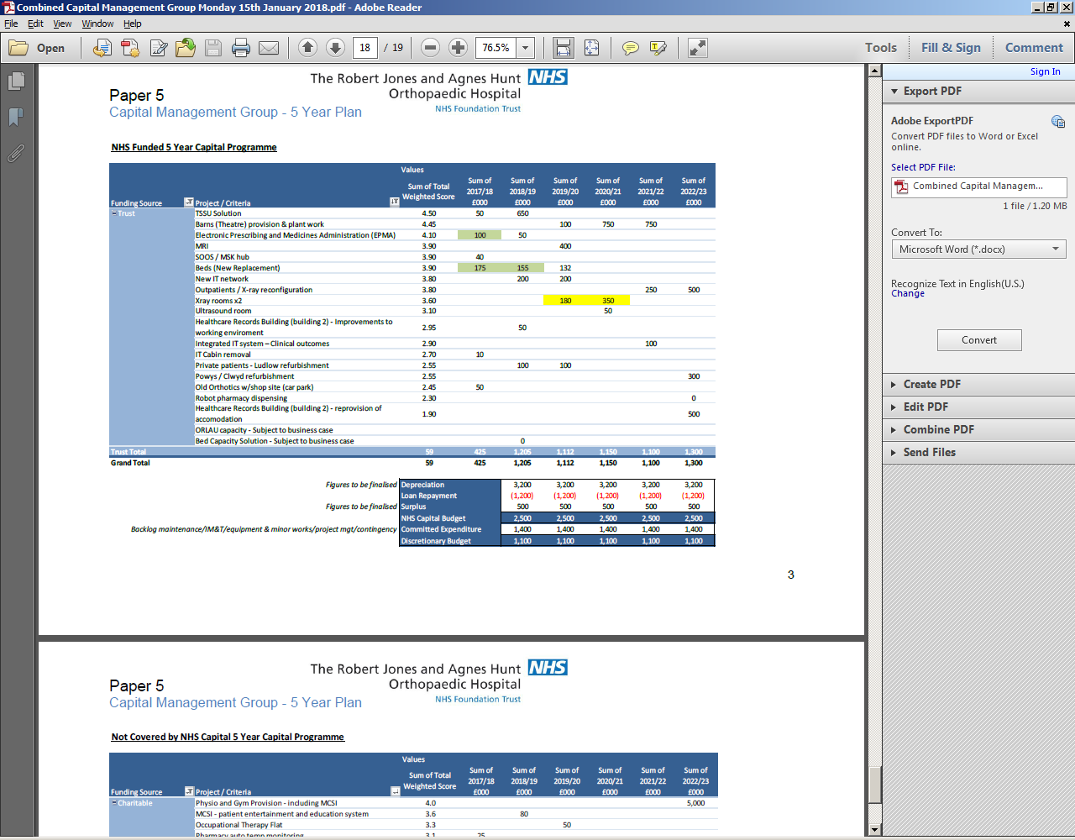

Additionally the Trust recognises the requirement to fulfil its aspirations through alternative funding sources for the following;

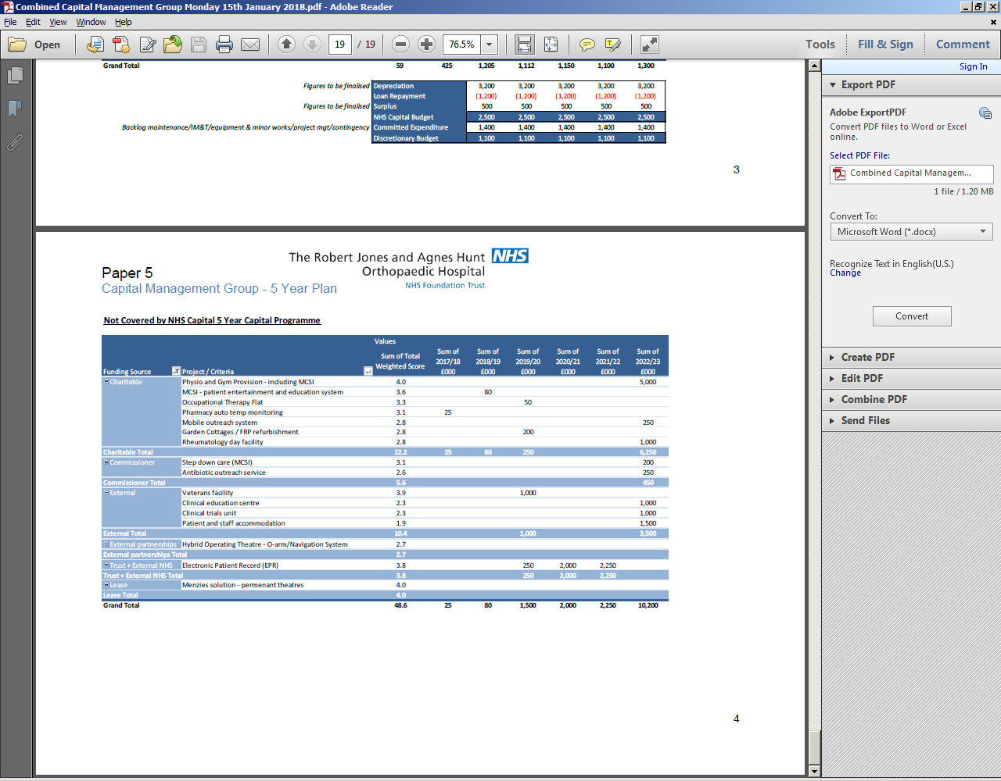

## Productivity, Efficiency and Cost Improvement Plans (CIPS)

We are developing a new approach to delivering our cost improvement plans, this will be a clinically focussed programme of work building on;

* Carter Model hospital
* Getting It Right First Time (GIRFT)
* Right Care Right Value

and the growing (and historical) evidence that optimising quality in healthcare leads to cost reductions. Indeed, evidence suggests that cost constraints actually drive quality improvement.

The cost reduction requirements for the Trust are significant. Incremental savings can no longer deliver what is required and there is a focus on continued quality improvement. With a back-drop like this, new ways of approaching cost reduction need to be investigated.

Research shows four main concepts that healthcare organisations need to concentrate on to achieve high quality care which costs less. These are:

* Improving quality
* Reducing variation
* Identifying and removing waste
* Cost Improvement Programme Profile

## Key Financial Risks

The Trust has reviewed all the key financial risks it faces and these are shown in the table below.

|  |  |  |  |  |  |
| --- | --- | --- | --- | --- | --- |
| Category of risk | Description of risk (including timing) | Potential impact | Mitigating actions / contingency plans in place | Residual concerns | How Trust Board will monitor residual concerns |
| Tariff Structural Changes & Business Rules  (BAF ref. 3.3) | Tariff deflator & impact of future business rules for each year | Every 0.5% decrease on tariff assumption equates to c£xk income reduction | Further efficiency savings required / service re-configuration / reduce capital spend / contingency reserve. | Future economic outlook and impact on tariff. | Regular updates to Committees of the Board and BOD on relevant issues and included on BAF |
| Welsh Contractual Framework  (BAF ref.1.5) | Withdrawal of PBR tariffs for cross border commissioners | Welsh contract not yet signed – impact unknown. | Local negotiation to ensure financial stability and sustainability. | Overall financial climate in Wales. Lack of support to English providers. | Regular updates to Committees of the Board and BoD on relevant issues and included on BAF |
| Contract Penalties & Non Delivery of CQUIN schemes  (BAF ref. 1.5) | Financial penalties within contract such as CDiff, E-Discharge, RTT, cancer etc and non-delivery of CQUIN schemes | 2% of service lines for majority of others | Robust action plans in place with a range of improvements being implemented. | Targets are very challenging,. | Robust performance monitoring and capital updates to Committees of the Board and BoD and included on BAF |
| Changes to Demand / service Reviews / Commissioner Tendering of services  (BAF ref. 1.5) | Reduction in activity such as further Welsh repatriation, loss of key services due to tenders etc | Reduction in income, and inability to realise cost savings. | Reduce capital spend / Review capacity and reduce associated costs / marketing of services to mitigate lost income | Inability to reduce costs equivalent to reductions in income. | Regular updates to Committees of the Board and BoD and included on BAF |
| Delivery of Efficiency Target  (BAF ref. 3.5) | Efficiency savings onwards not all identified or delivered | For every 0.5% not identified equates to £x pressure | Reduce capital spend / contingency reserve / review surplus required. | Any further increase to efficiency target due to risks identified above. | Regular updates to Committees of the Board and BOD and included on BAF |

# Governance

The Trust is following the recommendations made by Monitor and PWC in the Strategic Planning Self-Assessment Toolkit. It has assessed itself against the requirements outlined and is confident that it meets them. This is described below –

|  |  |
| --- | --- |
| To show that it has a strategic planning process in place that takes sure its board and executive team take the necessary planning actions at the right times, a provider must be able to answer “yes” to the following questions: | |
| Has the organisation put in place a structured strategic planning process to guarantee that the board and executive team regularly spend time discussing strategic issues?  *Yes, Strategic Development Framework* | |
| Do the board and executive team have strategic planning backgrounds and skills?  *Yes.* | |
| Do the board and executive team have an identified, responsible and skilled supporting staff to draw on when they carry out strategic planning?  *Yes – limited personnel.* | |
| Do the board and executive team have regular strategy discussions with a range of local health economy stakeholders (eg, commissioners and other providers) and understand their perspectives?  *Yes, including assessing the strategic intentions of our competitors/stakeholders.* | |
| To show that they have developed and refreshed a five to ten year strategic plan with content based on accurate and correctly analysed inputs, a provider must be able to answer “yes” to the following questions: | |
| Has the organisation quantified the risks to its clinical and financial sustainability and developed transformation plans by drawing on accurate inputs, including internal performance information and external market data, which it has analysed and presented correctly?  *Yes.* | |
| Can the board and executive team declare that their organisation will be financially and clinically sustainable according to current regulatory standards in one, three, five and ten years, if it keeps its current configuration and service profile*?*  *Partially* | |
| Has the organisation identified a vision that establishes why and how the organisation should change or transform, if necessary, in order to deliver high-quality and efficient patient care and address any sustainability gap identified?  *Yes – as described above.* | |
| Is that vision supported by plans for initiatives that can be shown to address any sustainability gap identified?  *Partially*   |  | | --- | | To show that they monitor delivery of their strategic initiatives, a provider must be able to answer “yes” to the following questions: | | Does the organisation have detailed delivery plans for each of its strategic initiatives that lay out milestones, resource requirements, dependencies and risk mitigations?  *These are currently being developed and will be integrated with our committee structures.* | | Does the trust have skilled staff to draw on to implement those delivery plans?  *Yes.* | | Are trust staff, patients and other stakeholders able to explain the ambition and initiatives of the provider when asked, and do they know what they must do to deliver both?  *Partially – focused on own service currently not wider organisation.* | | Are strategic plans reviewed and updated yearly to keep them relevant?  *Yes – annual plan.* | | |

The Trust has an established committee structure to oversee the progression of the strategy that reports ultimately to Board level. These include the Finance, Planning & Investment Committee, and the Strategy Oversight Group where the performance of the individual elements of the strategy will be assessed. Regular updates and communication will also be taken to –

* The Council of Governors
* Trust Leadership Briefings

# Consultation & Dependencies

The dependencies in relation to the implementation of the strategic plan are listed below, together with how these dependencies will be managed;

* *Commissioner support –* we have consulted with our main commissioner – Shropshire CCG – and they have confirmed their support and alignment with their commissioning plan for the locality. The Trust aims to become the integrator for MSK services. To do this the Trust must work with and alongside the services provided by the local authority, SATH and ShropCom and we have again consulted appropriately.
* *Provider collaboration* – The Trust has established a relationship with South Staffordshire and Shropshire NHS Foundation Trust (SSSFT) and has commenced a series of active discussions and initiatives with the Trust to deliver collaborative change.
* *Financial* – The combined delivery of our efficiency programme.

# Summary

In summary our strategic focus is both internal and external. Internally we aim to become as efficient as possible, providing the right services, at the right time, in the right place, whist meeting our quality standards, clinical outcomes, and the expectations of our patients.

Externally we have a key role to play, in conjunction with our other healthcare partners, in developing an integrated MSK care. This is by far the biggest challenge facing us and the wider health system, and is key to the wider sustainability challenge.

We are confident however that we will meet these challenges, and remain an effective, viable and high quality provider of healthcare, not just for 5 years, but over a much longer term.

# APPENDICES

1. **Market analysis and context**
   1. **Shropshire**
   2. **Telford & Wrekin**
   3. **North Wales**
   4. **Powys**
2. **Competitor analysis**
   1. **Direct competitors**
   2. **Indirect competitors**
3. **Impact on key service lines**
   1. **Orthopaedics**
   2. **Rheumatology**
   3. **Chronic Pain Management**
   4. **Geriatric Medicine**
   5. **Paediatrics**
   6. **Spinal Injuries**
   7. **Orthotics**
   8. **Orthotics Research Locomotor Assessment Unit (ORLAU)**
   9. **Sports Injuries**
   10. **Bone Tumour**
   11. **Therapies**
   12. **Radiology**
   13. **Pathology**
   14. **Pharmacy**

## Market analysis and context

*Background*

The Robert Jones and Agnes Hunt Orthopaedic Hospital NHS Foundation Trust (RJAH) has been an NHS Foundation Trust since August 2011. Our geographic location and specialist nature give a complex commissioning portfolio across the English Welsh Border and nationally for some services. The current turnover of the Trust is approximately £100 million and the Trust employs 1,217 whole time equivalent staff.

The Trust is one of the UK’s specialist orthopaedic hospitals providing specialist, routine orthopaedic and related care to patients locally, regionally and nationally. The hospital is an elective surgical centre for routine orthopaedics, and in addition, a specialist centre for complex orthopaedic surgery for both adults and children, a regional spinal injuries centre, and a national centre for bone tumour surgery.

The Trust has contracts with a number of commissioners. The largest English commissioner is the Shropshire County Clinical Commissioning Group (Shropshire CCG). The Betsi Cadwaladr University Hospital Board is the largest Welsh Commissioner followed by Powys Teaching Health Board. Commissioning for our specialised services is undertaken by NHS England, which is represented locally by the Birmingham and Black Country Local Area Team.

Our key areas of strength relative to our competitors are our long standing reputation for delivering quality clinical care highlighted by low infection rates, high rates of patient satisfaction and the support of our both local commissioners and population. Our challenges come from high demand for services where access is limited elsewhere in our health economy and the complex and specialist nature of the care we provide in some service lines e.g. spinal surgery.

### Shropshire

*Demography Challenges*

Shropshire has a population of circa 311,380 (2015), with an older age profile than is seen nationally. The population has a higher proportion of people aged over 65 than the national average and conversely the rate of people aged under 25 is lower than average.

The 45-59 age bands accounted for the largest proportion. All age bands aged 45 and over saw a proportional increase compared to 2001, whereas age bands younger than this saw proportions remain about the same or fall. This indicates how the overall population is getting older.

The median age in Shropshire was 44 in 2011 compared to 39 in the region and nationally. This has risen since 2001 from 41 years. These imbalances are set to increase.

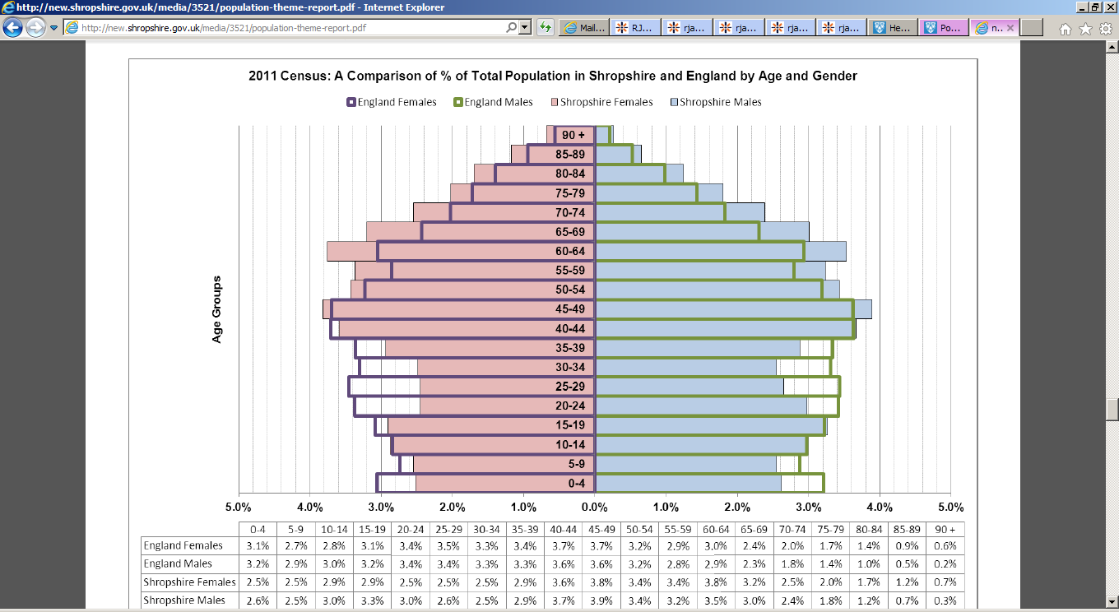

Shropshire experienced an 8.1% growth in population between 2001 and 2011 greater than both West Midlands (6.4%) and England and Wales (7.8%). Shropshire remains one of the least dense populations in England and Wales and far lower than average levels regionally and nationally with 0.96 people per hectare in 2011.

The population of Shropshire is projected to increase to 338,000 by 2031 an 8.5% increase from 2015. The Oswestry district is projected to experience the highest level of growth out of all the Shropshire districts, with North Shropshire expecting the second highest level of growth.

In Shropshire, the 65 to 84 year age group is projected to increase by 34,500 people by 2031, from 49,000 in 2006 to 83,500. Oswestry district is projected to experience the largest growth of 95.7%, followed by south Shropshire, with growth of 78%. The over 85 years age group is projected to increase by 194.6% (13,600 people) from 7,000 in 2006 to 20,600 in 2031.

Life expectancy is above the average for England, men at 80.2 years and women at 84.1 years compared to 79.5 and 83.2 respectively for England.

Shropshire’s ageing demographics mean that we will have more people living long enough to develop conditions of ageing, becoming frail and developing impairment.

The tables below illustrate the effect of demographics on the hospital activity to the year 2023 if there were no changes in the health system.

 

The tables clearly demonstrate the impact of an ageing demographic on services over time. We have used the detail of the impact of this on specific specialities to underpin our planning. However, what is stark is the impact the demography will have on demand and as a consequence cost. Our plans describe how we will seek to mitigate some of this risk with our local commissioners and partners.

*The Main Burdens and Risk Factors*

Through Shropshire’s Joint Strategic Needs Assessment the four key issues affecting the health of the population where identified as;

* Ageing population
* Health inequalities
* Lifestyle risk factors to health
* Long term conditions and non-communicable disease

*Deprivation*

Shropshire has a less deprived population profile compared to England, ranking 107 out of 152. Shropshire has nine lower super output areas that fall within the 20% most deprived areas in England, which are located within the urban areas of the county. One of those areas falls within the 10% most deprived in England.

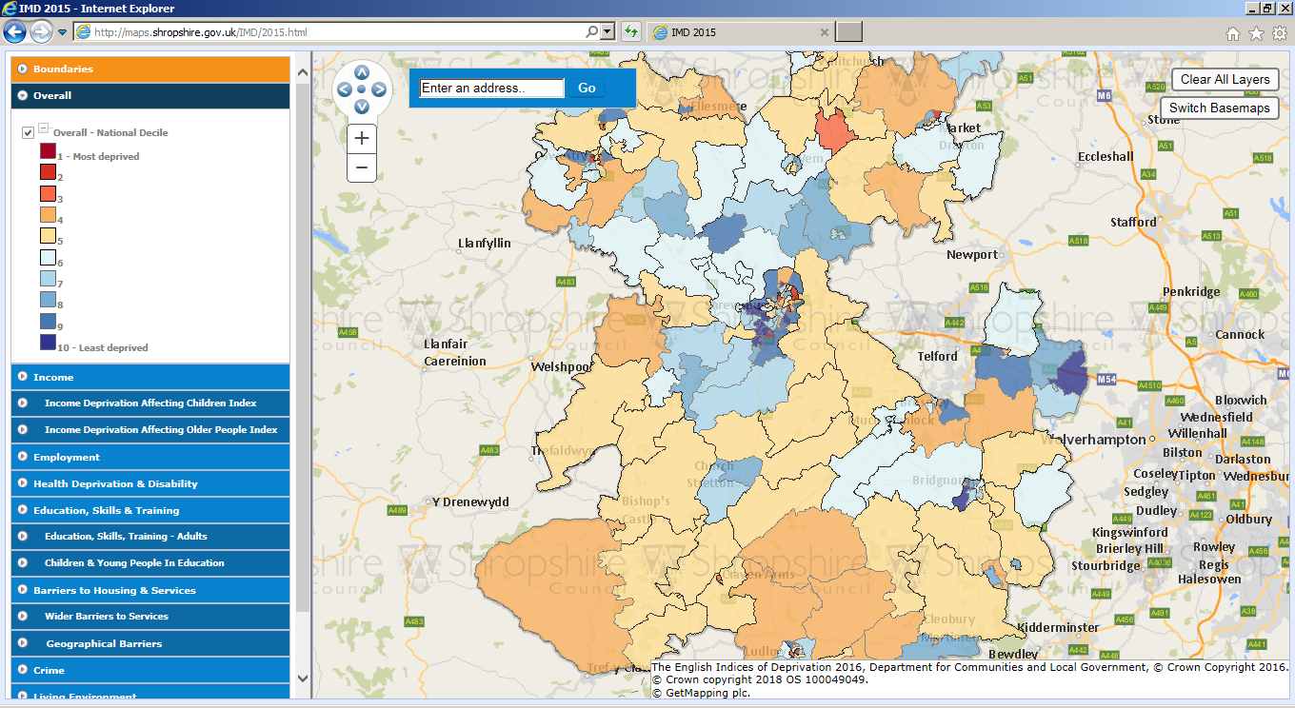

*Physical Activity*

An active lifestyle is important in reducing and preventing diseases such as musculoskeletal conditions, 16.1% of people aged over 16 years in Shropshire were moderately physically active for at least 30 minutes on three days per week, similar to the national figure of 16.6% However, lifestyle surveys highlight that physical activity in Shropshire decreases with age, with people living in the most deprived areas less likely to be physically active than those in more affluent areas.

Lack of physical activity increases the risk of poor health outcomes such as coronary heart disease (CHD), stroke, type 2 diabetes, depression, dementia, some cancers and increased risk of falls and hip fractures in older adults.

*Weight*

Obesity prevalence in Shropshire is similar to national figures and accounts for a large and growing burden of disease. Obesity is not spread equally throughout the population and inequalities exist, for example people in older age groups and those living in the most deprived areas of Shropshire are more likely to be obese than the average. As there is an ageing population in Shropshire, obesity is likely to increase in line with this. With Shropshire being a relatively affluent county with fewer areas of disadvantage the fact that there are similar levels of obesity to the national average is a matter of concern.

*Falls*

One in three over 65s and one in two over 80s fall each year. Injuries sustained from falls are one of the most common causes of death in people aged 75 years old and over. There is a high possibility for people who have fallen to have repeated falls after an initial fall. Aside from increased risk of death as a result of falling, there is also an increased risk of disability, loss of self-confidence and reduced quality of life. There are many risk factors for falls in older people including medication, reduced strength and balance, dementia, acute and chronic medical conditions, alcohol misuse, poor vision, inappropriate footwear and environmental factors. Osteoporosis can potentially increase the risk of a fall and result in serious injuries such as fractured neck of femur.

In Shropshire admissions to hospital from falls increase with age and there are significantly more admissions from females over the age of 75 years old. This is important due to the fact there are large numbers of people aged 75 year and over in Shropshire and the population in this age groups is expected to continue increasing.

*Dementia*

Most people affected by dementia area age 65 years and over and the likelihood of having dementia increases with age. This is important locally due to the fact Shropshire has a higher proportion of older people than the national average and the population aged 65 years and over is expected to continue increasing.

In Shropshire it is thought that just over 7% of people aged 65 years and over have dementia, the figures are higher for women (8.5%) than men (5.5%). This figure is expected to increase to 7.5% for all people aged 65 and over by 2021. The expected increase in Shropshire is likely to be at a faster pace than for the expected increase in England overall. Prevalence estimates for dementia are thought to be more than double the recorded rate in Shropshire.

*Cancer*

Cancer is the second most common cause of death in Shropshire accounting for 27% of deaths annually. In Shropshire there is a similar premature cancer mortality rate compared to the national figures and overall premature mortality has declined in the last two decades.

*Financial Challenges*

For the year ending 2016/17 Shropshire CCG had a very challenging previous 12-24 months, with a deteriorating financial position and entry into both special measures and legal directions. This has seen a number of accountable officers join and leave the organisation, which remains with a significant recurrent and cumulative deficit, which will need to be addressed going forward. The CCG has developed a Financial Recovery Plan that will seek to return the CCG to a recurrent balance over a number of years.

The 2016/17 deficit for Shropshire CCG was £25.98 million. It should be noted that this year’s deficit, when added to the deficit from 2015-16 of £10.89m, results in a cumulative deficit of £32.65m.

In both Shropshire and Telford & Wrekin, demand for health and social care services will outstrip the funds available by £131.4 million, by 2020/21.

*Clinical Quality Challenges*

In terms of referral to treatment for non-urgent consultant led services, at the end of March 2017, Shropshire achieved 88.65 per cent of patients waiting under 18 weeks for treatment. There were nine Shropshire patients that had been waiting over 52 weeks for treatment. 99.7 per cent of patients waited less than six weeks for diagnostics.

Shropshire did not meet the recovery trajectory submitted for A&E waits, however there was improvement toward the end of the financial year with 81.6 per cent of A&E attendances waiting less than 4 hours in March 2017.

Performance against the range of cancer targets was generally good throughout the year. With some exceptions in relation to two-week wait targets for possible breast cancers and 62 day wait urgent referrals.

During 2016/17, there was an increase in Never Events affecting Shropshire patients, compared to the previous year’s figures.

Shropshire have maintained low levels of MRSA blood stream infection and Clostridium Difficile infection. In 2015/16, and in 2016/17 (as at month 11), there were no incidences of MRSA reported at a CCG level. In 2015/16, 87 incidences of Clostridium Difficile were reported against an objective of 73. As at month 11 (February 2016/17), there had been 53 incidences reported against an objective of 73.

### Telford & Wrekin

Telford & Wrekin (T&W) has a population of circa 169,400 (2016), conversely to Shropshire the population of T&W is younger than the national average, similarly the fastest growth continues to be in the 65+ year old age groups.

The population of the county is projected to grow at a faster rate than the England population, 13.4% versus 10.2% this increase will be c. 23,300 people. Over half the increase will be in the over 65 age group with the 85+ age group more than doubling and the 65 to 84 years old increasing by a third.

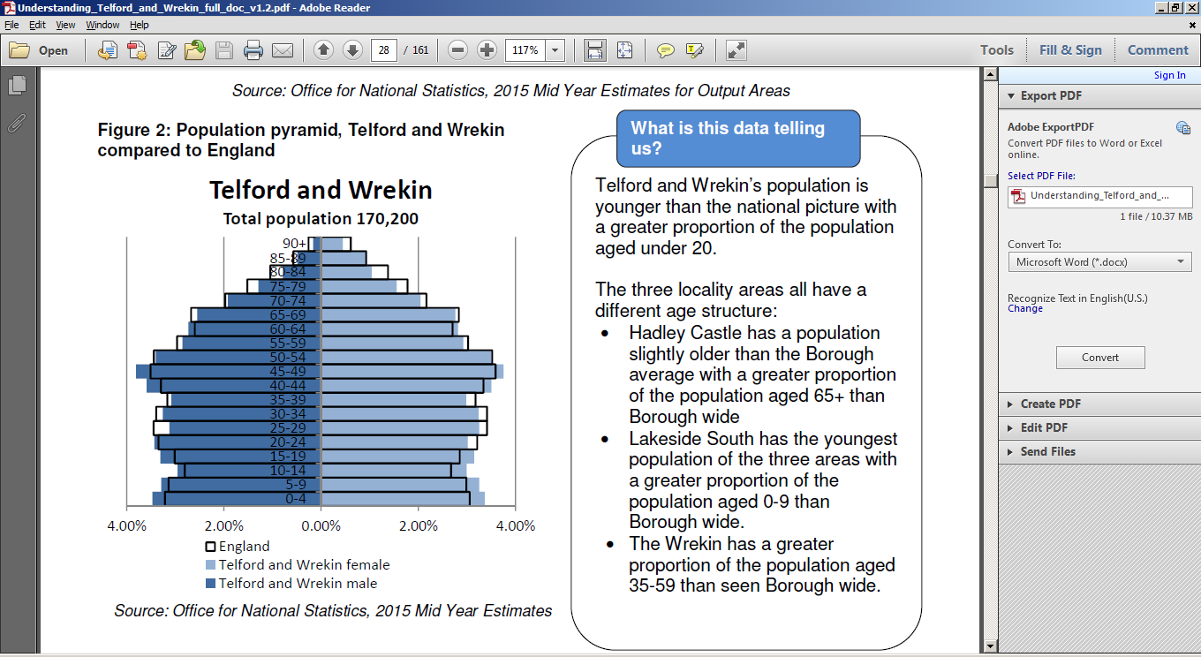

Life expectancy, in contrast to Shropshire, is below the average for England, men at 78.7 years and women at 81.8 years compared to 79.5 and 83.2 respectively for England.

In 2017, 5,310 T&W residents were registered with GP’s outside T&W, 99% were registered with GP’s in Shropshire. Conversely, 6,319 patients registered with T&W GP’s were resident outside the county.

*The Main Burdens and Risk Factors*

The three cross-cutting priorities for T&W Health and Wellbeing Board are;

* Encourage healthier lifestyles
* Improve mental wellbeing and mental health
* Strengthen our communities and community based support

*Deprivation*

In contrast to Shropshire, T&W is a place of socio-economic contrasts with parts of the county amongst the most deprived nationally (comparable with inner cities) and areas amongst the least deprived nationally. There are 15 areas ranked in the 10% most deprived nationally with more than a quarter (27%) of T&W population living in the 20% most deprived areas nationally.

*Physical Activity*

An active lifestyle is important in reducing and preventing diseases such as musculoskeletal conditions, the Sport England Active People survey results showed 28.5% on adults as being inactive in 2015, a rate similar to that in all of England.

Lack of physical activity increases the risk of poor health outcomes such as coronary heart disease (CHD), stroke, type 2 diabetes, depression, dementia, some cancers and increased risk of falls and hip fractures in older adults.

*Weight*

The proportion of children in reception with excess weight in increased to 25.5%, worse than the England (22.1%). In Year Six children with excess weight increased to 37.4%, worse than England (34.2%). Levels of excess weight in adults are 71.1% and obesity 26.5%, both worse than England.

*Dementia*

Around 1,800 residents aged 65 & over suffering from dementia. Most people affected by dementia area age 65 years and over and the likelihood of having dementia increases with age.

*Cancer*

There has been an increasing trend of incidence of all cancer types in T&W, in the most recent period reporting this has fallen. The standardised incidence ratio for all cancers in T&W is similar to the national ratio.

*Financial Challenges*

For the year ending 2016/17 T&W CCG achieved an overall surplus of £5.786m. The 2017/18 QIPP requirement for T&W CCG is £6.9m target and an average QIPP target of approximately £7m for future years.

*Clinical Quality Challenges*

In terms of referral to treatment for non-urgent consultant led services, at the end of March 2017, T&W achieved 87.1 per cent of patients waiting under 18 weeks for treatment. There were six T&W patients that had been waiting over 52 weeks for treatment. 99.7 per cent of patients waited less than six weeks for diagnostics.

T&W did not meet the recovery trajectory submitted for A&E waits, however there was improvement toward the end of the financial year with 81.8 per cent of A&E attendances waiting less than 4 hours in March 2017.

In partnership with Shropshire CCG a focus on serious incidents and never events due to a trend during 2016/17, there was an increase in Never Events affecting Shropshire patients, compared to the previous year’s figures.

### North Wales

There are a number of hospitals across North Wales;

* Ysbyty Gwynedd (Bangor)
* Ysbyty Glan Clwyd (Bodelwyddan)
* Ysbyty Maelor (Wrexham)
* Ysbyty Llandudno
* Ysbyty Abergele

*Demography Challenges*

RJAH geographical position places it on the border of Wales and therefore covers the catchment area for RJAH from North Wales is predominantly from Betsi Cadwaladr University Health Board (BCU HB) and Powys Teaching Health Board (Powys). The population of North Wales is approx.. 670,000 and is predicted to grow to almost 700,000 by 2028.

18.5% of the resident population of North Wales is aged 65 and over, and the largest growth area over the next 30 years is anticipated with older people.

The population is scattered between large concentrations of people in and around the region’s key urban centres, coastal resorts and rural market towns and smaller concentrations in and around rural villages, hamlets and settlements.

*The Main Burdens and Risk Factors*

Mortality

For males, life expectancy at birth in BCU HB is 78 years, females in BCU HB have a life expectancy of 82 years.

Deprivation

122,181 people are recorded as living within the most deprived wards which are located within North Wales (i.e. approx 17% of the total population living within the most deprived wards in Wales).

*Physical Activity*

Similarly to Shropshire a third of adults in BCU HB currently participating in at least 30 minutes of moderate intensity physical activity on five or more days a week.

*Weight*

Over half the adult population (58%) in BCU HB are overweight or obese.

*Cancer*

There is a long term trend of increasing numbers of new cancer cases in the population of Wales. Cancer accounts for about 30% of all deaths in males and 25% in females.

*Financial Challenges*

The financial position of BCU remains a cause of concern, Health Boards are required to balance their income with expenditure over a rolling three-year period; a requirement which BCU have been unable to meet. In 2016/17 BCU overspent by £29.8m pounds.

BCU did not manage its revenue expenditure within its resource allocation over this three year period. The cumulative revenue resource limit of £3,991million over the three years was exceeded by £75.9 million.

*Clinical Quality Challenges*

BCU has determined it has nine principal risks to achieving its corporate goals:

* Failure to maintain the quality of patient services
* Failure to maintain financial sustainability
* Failure to manage operational performance
* Failure to sustain an engaged and effective workforce
* Failure to develop coherent strategic plans
* Failure to deliver the benefits of strategic partnerships
* Failure to engage with patients and reconnect with the wider public
* Failure to reduce inequalities in health outcomes
* Failure to embed effective leadership and governance arrangements.

The rate of C-Diff cases per 100,000 of the population is on a downward trend but remains above the England benchmark.

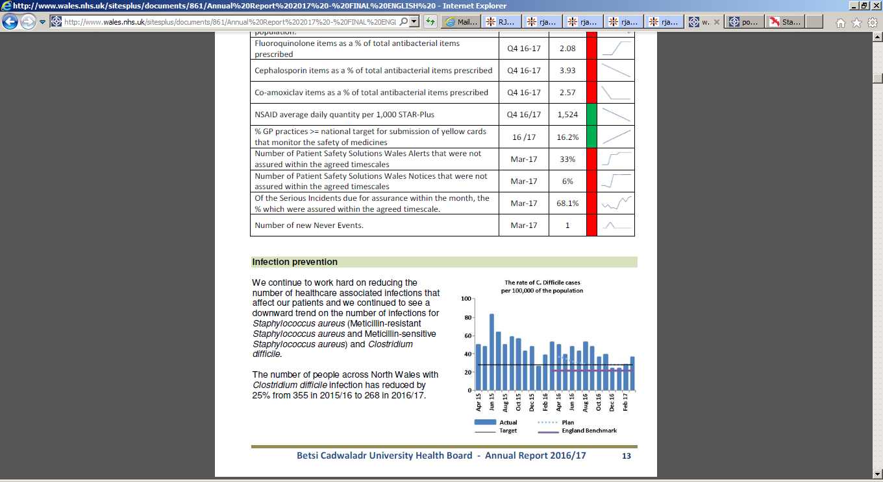

The referral to treatment targets for Wales are that 95% of patients are treated within 26 weeks and

that no patients wait longer than 36 weeks. BCU did not hit these targets in 2016/17 at the end of March 2017 87.2% of patients were waiting for less than 26 weeks.

### Powys

Secondary care services for Powys are provided through commissioning arrangements with other health boards in Wales and NHS Trusts in England.

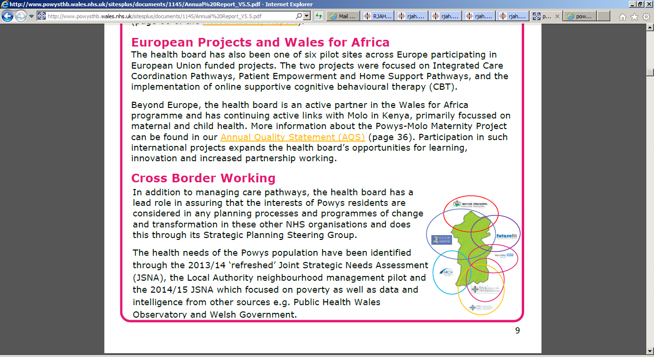

*Demography Challenges*

RJAH geographical position places it on the border of Wales and therefore covers the catchment area for RJAH from North Wales is predominantly from Betsi Cadwaladr University Health Board (BCU HB) and Powys Teaching Health Board (Powys). The population of Powys is approx. 132,160, conversely to Shropshire, T&W and BCU, Powys projects an overall decline in its population by 8% by 2039.

The population of children and young people in Powys is predicted to decrease within the next ten years, mainly due to an on-going trend for young people to leave the county in favour of more urban areas, as well as the reduced birth rate across Powys. However, the number of those aged over 65 and 75 will rise faster in Powys compared with Wales. The 65+ age group in Powys is projected to increase by 37% by 2033 and the 85+ population is estimated to increase by 121% over the same time period in Powys.

*The Main Burdens and Risk Factors*

Deprivation

Powys is the most deprived local authority in Wales, with 42 lower super output areas amongst the least affluent 10% of areas in Wales.

*Physical Activity*

39 per cent of adults reported being physically active on 5 or more days in the past week, higher than the Wales national average of 31%. Powys residents aged over 65 years are more engaged in healthy behaviours compared with older people across Wales 24% versus 17%.

*Weight*

Over half the adult population (58%) in Powys are overweight or obese, with 1 in 4 children entering school overweight or obese.

*Cancer*

The four most common incident cancers in Powys are prostate, female breast, colorectal and lung cancer, with the incidence of cancer significantly lower than in Wales, there are an estimated 4,763 Powys residents living with a cancer diagnosis.

Dementia

Dementia prevalence increases with age, roughly doubling every five years for people aged over 65 years. In Powys it is thought that only 39.6% of the projected number of people with Dementia have a diagnosis, with an estimated 4,256 people in Powys aged over 65, at 44% Powys has the highest projected rise in the number of people with dementia in Wales.

*Financial Challenges*

The financial performance of Powys met the requirements of Welsh Government in that revenue and capital expenditure were contained to within the resources available for the 2016/17 financial year, this performance has been achieved for three successive years.

*Clinical Quality Challenges*

At the end of March Powys had 365 patients waiting longer than 36 weeks for treatment and of these 44 patients (0.4%) were waiting longer than 52 weeks. 55 serious Incidents were reported in 2016-2017, most of these related to Pressure Damage and Patient falls.

## Competitor Analysis

The competitive analysis for RJAH has been carried out to consider the competitive dynamics, threats and opportunities that exist, being an essential and integral element of our strategic planning. The analysis identifies and assesses the current competitive environment that RJAH operates within together with likely trends in our local health economy. Therefore the analysis looks to identify present and future threats to our services together with opportunities for expansion or potential partnership working.

The competitors in the environment that RJAH operate have been categorised as direct – providers that currently offer the service, in the same type of care setting within our geographic area, indirect - providers that currently offer the service, but in a different care setting and/or different geographic area.

### Direct Competitors

The predominance of competitors within RJAH’s environment is other NHS Trusts. This section will provide an overview of those competitors at a macro level, focusing more in depth on those geographically closer, followed by detailed analysis of specific service lines.

***Shrewsbury & Telford Hospital NHS Trust (SATH)***

SATH serves predominantly the Shropshire, Telford & Wrekin locality. SATH is a district general hospital with two sites, c. 700 beds serving a population of nearly half a million. The Princess Royal Hospital site opened in 1989 and the new Shropshire Women and Children’s Centre at the hospital opened in September 2014. This hospital site is 34 miles away from RJAH. The Royal Shrewsbury Hospital site opened in 1977 but has undergone major updates to its facilities including a £25 million investment in a Treatment Centre and £5 million in the Lingen Davies Centre. This hospital site is 18 miles away from RJAH.

The majority of the Trust’s services are provided at the Princess Royal Hospital (PRH) in Telford and the

Royal Shrewsbury Hospital (RSH) in Shrewsbury; providing 99% of Trust activity. Both hospitals provide a

wide range of acute hospital services including accident & emergency, outpatients, daycases, diagnostics, inpatient medicine and critical care. Following recent service reconfigurations, inpatient adult Surgery (excluding breast) is provided at RSH, with Women and Children’s Services (consultant-led obstetrics, neonatology, inpatient and daycase paediatrics and inpatient Women’s Services), head and neck and acute stroke care being provided at PRH. Elective orthopaedics is delivered at The Princess Royal Hospital site.

The Trust has achieved a teaching status through its partnership with the Keele University School of Medicine, it also has strong links with Birmingham and Manchester. Not to mention a partnership with Staffordshire University in the training of nurses and allied health professionals.

Similarly to RJAH, SATH is serving a relatively high elderly population with a relatively low proportion of people in their 20’s and 30’s.

SATH’s vision is “to provide the safest and kindest care in the NHS”, with their mission to have the “healthiest half million population on the planet”

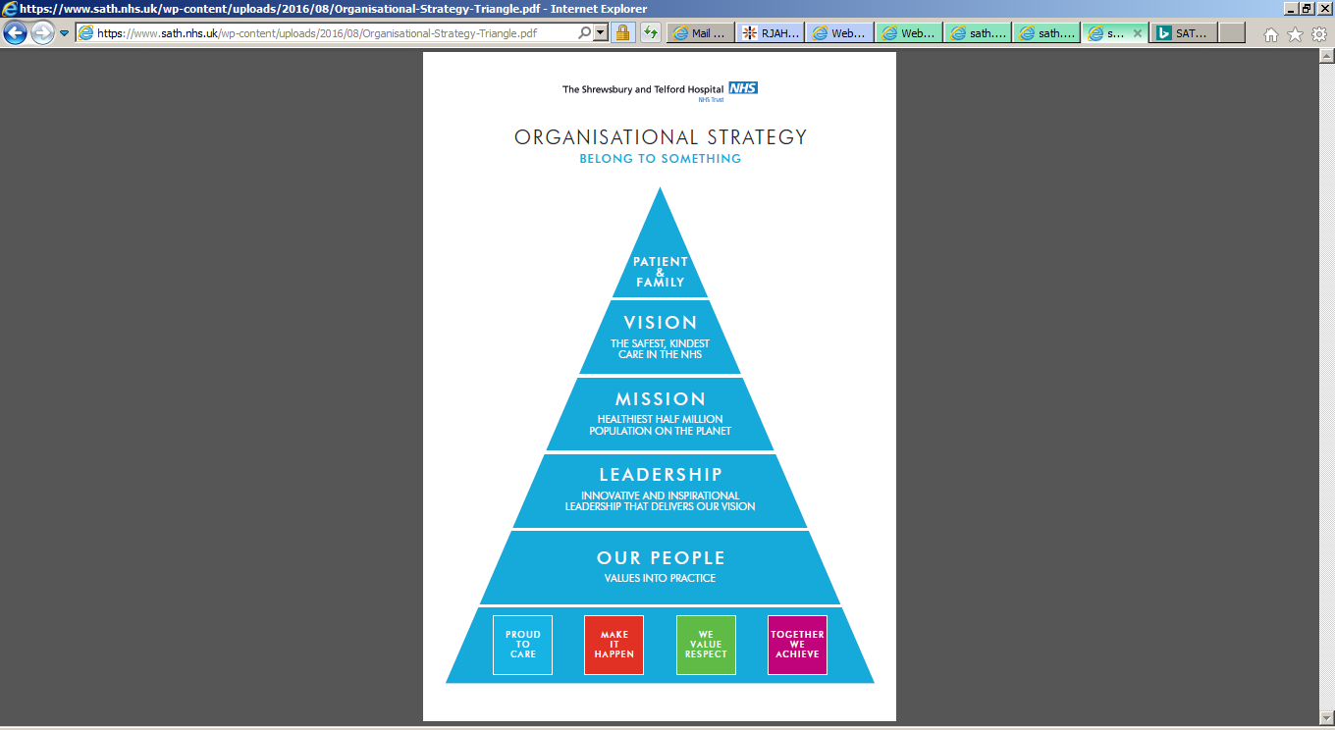

The Trust strategy has a large emphasis upon the STP process and sees that it is key that they are leading two of the five key pieces of work, namely the Deficit Reduction Plan and the Sustainable Services Programme (a part of the Future Fit programme).

The Sustainable Services Programme (SSP) Strategic Outline Case (SOC) was approved by their Trust Board on 31 March 2016 and submitted to Commissioners and the TDA. The SOC describes potential solutions to the delivery of the Future Fit Clinical Model of one Emergency Centre (to include a single Emergency Department and a single Critical Care Unit) and two Urban Urgent care Centres.

A key driver of that cultural change for SATH is the Transforming Care Programme. As one of five Trusts in England selected to work in partnership with the Virginia Mason Institute in 2015, the Trust has embarked on its journey of continual improvement. With patients at the centre of all value-streams and with a ‘zero-tolerance’ approach to avoidable waste and defects.

SATH does not have all the staff it needs in the right locations. The organisation is faced with difficulties in recruiting to essential medical and nursing clinical roles; within the Emergency Departments, Critical Care services and other areas across the Trust. This means a heavy reliance on temporary staff and increased pressure on teams.

The backlog maintenance across both main hospital sites is estimated at £10 3.5 million, which includes £50.3 million of items assessed as high or significant risk.

***Betsi Cadwaladar (BCU)***

BCU has a number of hospitals across North Wales;

* Ysbyty Gwynedd (Bangor) – 77 miles from RJAH
* Ysbyty Glan Clwyd (Bodelwyddan) – 45 miles from RJAH
* Ysbyty Maelor (Wrexham) – 13 miles from RJAH
* Ysbyty Llandudno – 61 miles from RJAH
* Ysbyty Abergele – 49 miles from RJAH

BCU are in the process of developing their medium term plan, however they have determined it has nine principal risks to achieving its corporate goals:

* Failure to maintain the quality of patient services
* Failure to maintain financial sustainability
* Failure to manage operational performance
* Failure to sustain an engaged and effective workforce
* Failure to develop coherent strategic plans
* Failure to deliver the benefits of strategic partnerships
* Failure to engage with patients and reconnect with the wider public
* Failure to reduce inequalities in health outcomes
* Failure to embed effective leadership and governance arrangements.

The mean level of referrals from GP’s across Wales is 3,036 referrals per 100,000 population, hence there are c. 30,500 referrals per annum for elective orthopaedics in North Wales. Welsh Government guidance states that all Community Musculoskeletal Assessment and Triage Service (CMATS) should identify alternatives to referral to secondary care orthopaedic services for a minimum of 30% of patients referred to them. The CMATS in North Wales currently refers 43.6%

Referral rates from GP’s in North Wales are the second lowest in Wales and lower than the English average per 100,000 population at a mean of 2,588.

|  |  |  |  |  |  |  |
| --- | --- | --- | --- | --- | --- | --- |
|  | Current Capacity | Current Demand | Recurrent Capacity Gap | Planned Productivity Improvements | Demand Growth | Additional Recurrent Capacity |
| BCU IP | 5,997 | 7,784 | 1,787 | 488 | 1,790 | 3,089 |
| BCU OP | 13,799 | 15,003 | 1,204 | 550 | 3,447 | 4,101 |

BCU as at 31st March 2017 have a backlog of 2,898 patients that have been waiting over 36 weeks for elective orthopaedic treatment

Orthopaedics is a priority areas for BCU which has been reviewed in 2011, 2015 and again in 2017. It is anticipated that strategic case outline will be presented to BCU HB this financial year.

***Shropshire Community Health Trust (ShropCom)***

In December 2016 ShropCom reached a conclusion that the best option for the organisation is not to carry on as a standalone organisation due to the real limitations imposed by its small scale, this view was supported by NHSI. ShropCom have been lobbying for a partner which was financially stable, with good quality standards, experience in community delivery and real interest in Shropshire.

NHSI have convened a sustainability board chaired by NHSI, whose role it is to consider what type of organisational form would be best for those services and how to procure that will be for NHSI to determine.

ShropCom have a variety of services, there are a number that fit with the definition of MSK services as per below;

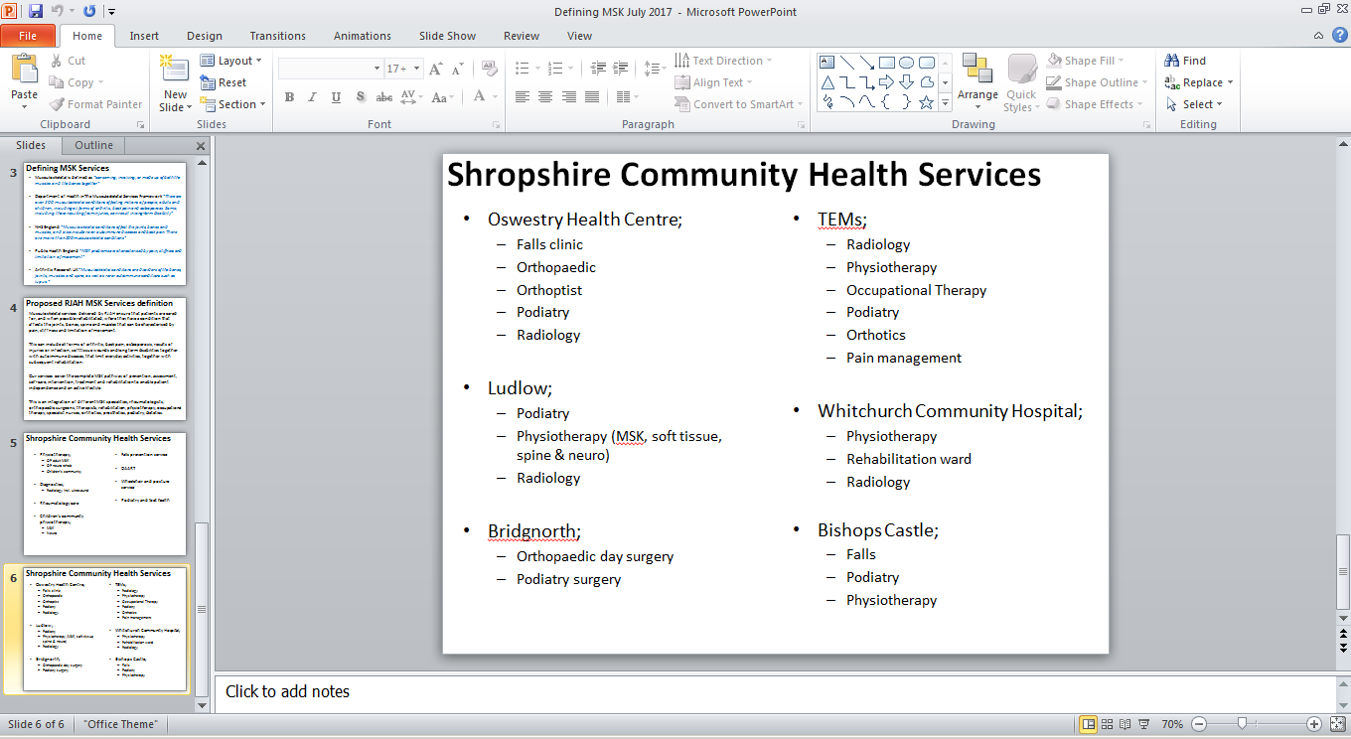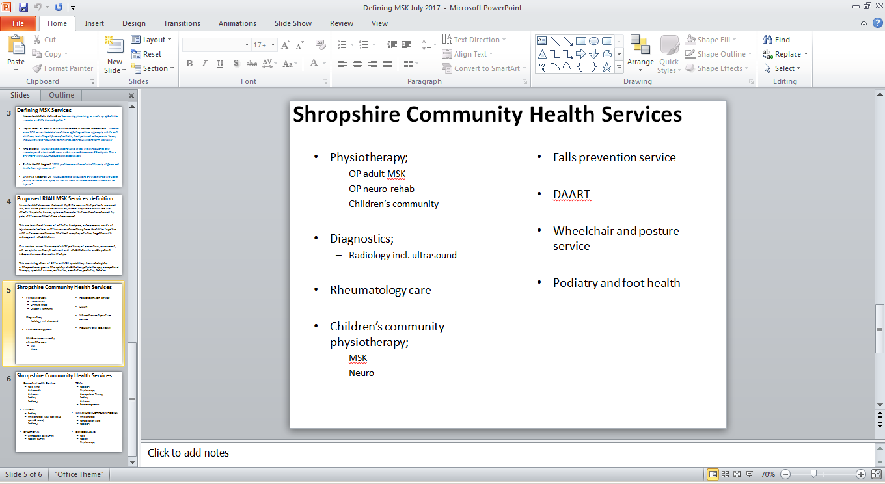

***Nuffield***

In Shrewsbury is The Shrewsbury Nuffield Hospital which is a not for profit organisation where profits are reinvested into improved facilities for patients. The Nuffield is a private hospital with all rooms (30) being private en-suite facilities which deliver a range of services where numerous RJAH employed consultants work at privately. The facility has three operating theatres, an endoscopy suite and an outpatients department which includes physiotherapy and diagnostic imaging.

The Nuffield does provide NHS work and is commissioned for orthopaedic work, it specifies that it specialises in the area of orthopaedics.

*Summary*

There are a number of competitors to RJAH in the local health environment. There are strong drivers for collaboration, all of the NHS Trusts are in close proximity servicing similar population numbers with a full range of DGH services.

### Indirect Competitors

This section will provide an overview of competitors of similar services but in different geographical settings that could potentially provide a threat to CoCH in the longer term.

***GHG Group encompassing BMI Healthcare & Netcare UK***

This group currently has 61 hospitals in the UK, it also provides surgical centres, marketing orthopaedic services.

***Virgin Care***

Virgin Care has been active in the area of MSK and physiotherapy services, with bases in;

* Bristol
* Bath
* Staffordshire
* Luton
* Dorset
* Surrey
* Hampshire
* Preston
* Lancashire
* Wirral (incl. community orthopaedic service)

***Care UK***

This group currently has nine hospitals, which offer a range of diagnostic services as well as inpatient and day services for patients who need surgical treatment. Orthopaedic treatment is offered at;

* Barlborough, Chesterfield, Derbyshire.
* Devizes, Wiltshire
* Emersons Green, Bristol
* Ilford, Essex
* Shepton Mallet, Somerset
* Southampton
* St Mary’s, Portsmouth
* Peninsula, Plymouth
* Will Adams, Kent

Care UK also operate two clinical assessment and treatment services (CATS) for musculoskeletal conditions;

* East and West Lincolnshire MSK CATS
* NHS Buckinghamshire MSK Integrated Care Service

***InHealth***

Provide a range of services that could compete with RJAH, predominantly diagnostic & imaging services, but also MSK physiotherapy

Summary

Currently there is no significant movement of these indirect competitors entering the local area, the services which they provide and their current ambition to bid in competitive tender could provide a threat to RJAH especially when consideration is given to the funding of their bid teams to secure healthcare work that fits with their organisational strategy.

## Impact on key service lines

Being a Foundation Trust, RJAH ensures a viable organisation through producing an annual surplus. As with any business the margin produced by different Divisions and sub-specialties can vary, recognising that the national trading business model is built upon payment by results and the resultant tariff.

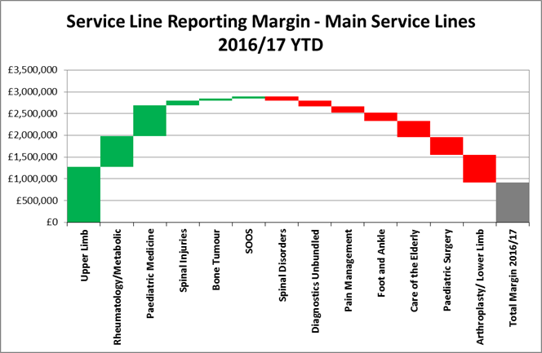

The five year strategy of RJAH is predicated upon a changing business model which has already commenced with local negotiations surrounding the payment mechanisms to reflect the operational and clinical effectiveness required.

Being predominantly elective care based business the sustainment of profitability margins is key both demonstrating the efficiency of our services in a business model with an ever decreasing tariff increasing the efficiency of already profitable services and reducing the loss in other through a range of initiatives of which there is still an appetite to continually improve.

The back bone to both elements of the business models described is our diagnostics services which have been evolving over the last three years due to the increased reliance on diagnostics. This has entailed changing delivery models in pathology which is anticipated to continue to evolve in the next five years in response to what is forecast to be ever increasing demand both internally to the hospital.

The next five years creates a challenge for all NHS organisations to ensure services that are sustainable financially, operationally and clinically. However, RJAH have been laying a solid foundation in the last 18 months to a changing model of operation which will be implemented and sustained over the coming five year period. This will be implemented differently in our three strategic themes but with an overarching umbrella of aspiring to deliver world class patient care. What follows is the impact to our key service lines within that five year period.

### Orthopaedics

RJAH provides a comprehensive range of orthopaedic elective services organised by sub-specialty covering the following;

* Upper limb
* Spinal disorders
* Foot and ankle
* Arthroplasty
* Lower limb

The market share of the service across its local commissioners is stable, as follows;

* Shropshire IP 76.29%, OP 47.76%
* Telford IP 23.48%, OP 14.16%
* BCU IP 79.07%, OP 36.03%
* Powys IP 73.53%, OP 51.85%

* Note that Welsh market share is based upon Welsh activity carried out in England not total Welsh activity.

In terms of clinical performance measures there is a mixed picture outpatients new / follow up ratios, outpatient DNA rates, average length of stay and mortality rates are marginally above those of its peers. Conversely it has lower complications rates, lower readmission rates compared with its peers.

As with a specialist orthopaedic hospital, services are broken down to sub-speciality level with the detail of each sub-speciality service being developed throughout this financial year.

Overall the sub-specialties services perform well both clinically and financially, therefore the decision on the future of the service at RJAH will depend on:

* The future direction for the services nationally, particularly in relation to the Briggs report and specialised commissioning.
* The increasing trend to consolidate services into a smaller number of providers may affect the services.

### Rheumatology

Rheumatology is a key service in NHS England’s MSK High Impact strategy and in Shropshire’s MSK redesign along with orthopaedics and pain services**.** The service is consultant led and delivered by a multi‐disciplinary team (MDT) in a hub and spoke model with out‐patient clinics running at RJAH, Shrewsbury, Whitchurch and Newtown. The clinical team provide a monthly clinic at Ludlow and Newport, as well as full time clinics at TeMS which are run by SCHT. At RJAH there is a day case facility for drug infusions and ultrasound guided joint injection clinics, 4 in‐patient beds on Sheldon ward for assessment and rehabilitation and hydrotherapy which patients from all outreach clinics can access via the physiotherapy department. The service is well established with over 3,800 patients on the follow up waiting list and is well thought of by patients, many of whom rely on the support provided through access to the nurse led helpline service and physiotherapy.

Referral rates have been steady over the last 2 to 3 years but a gap between demand (referrals) and capacity (consultant capacity) has led to lengthening waiting times and rising waiting lists for outpatient attendances. Waiting times in Physio and OT were also found to be unacceptably long and there was no access to podiatry or psychology. Owing to this shortfall, the service did not currently meet national quality standards for inflammatory arthritis (NICE guideline 79 and QS 33), nor some British Society for Rheumatologists (BSR) standards for out‐patient care. Standards for in‐patient and day case care are being met and there were areas of excellent practice observed, for example the nurse led helpline.

Commissioners have recently invested in the service to improve the quality of care for patients and from December all initiation, titration and monitoring of patients on disease modifying anti rheumatic drugs (DMARDs) will take place in this specialist service with shared care agreements with GPs once patients are stabilised on their dose.

The Rheumatology service line made a contribution to the Trust of £474,000 in 2016‐17.



It is anticipated that this service will expand some of the specialised commissioning services provided. The service has a good market share with our main local commissioner, Shropshire. For outpatients in 2016/17 this is 63.1% and 51.91% for inpatients, Telford 41.55% for inpatients and 6.85% for outpatients, BCU 36.5% for inpatients and 62.04% for outpatients, Powys 53.5% for inpatients and 74.24% for outpatients. The service also makes a positive reporting service line margin.

A current service review recommendations to ensure a sustainable workforce and a more modern patient pathway is implemented will be key in delivering the service changes over the coming year.

### Chronic Pain Management

Although chronic pain arises from a wide variety of sources, chronic pain services arose as an orthopaedic sub-specialty largely because the orthopaedic specialist hospitals where initiators in providing such a service for these vulnerable patients. The techniques used for anaesthetising orthopaedic patients to cope with the first few post-operative hours or days of acute care was transferable.

The reliance for this service in as an orthopaedic sub-specialty could be described as an anachronism as chronic pain is now recognised and treated in all areas of medical care and requires a multi-disciplinary approach encompassing psychological, medical and anaesthetic teamwork.

Chronic pain management does have a shortage of NHS practitioners together with a poor evidence base for treatments offered, hence a heavy reliance on treatments which are now being classed as ‘procedures of low clinical value’.

The Trust is reviewing this service noting;

* The current service does not include any psychological input.
* The service is currently operating with a single consultant.
* Financially there is a negative contribution from this service.
* Recent commissioning changes have meant that the main activity completed in this sub-specialty fall within the value based commissioning arrangements.

The current service is provided to patients predominantly with back pain, as such the patients can be classified into two groups those who require surgery and those that do not.

For those not requiring surgery, conservative management principles could be applied as defined by our spinal surgeons, experts in this area. Should patients require injection treatments this could be provided by our spinal surgeons, radiologists or anaesthetists subject to spinal surgeon decision protocols. Following injection the patient would return to GP care with an appropriately defined treatment plan.

### Geriatric Medicine

Care of the Elderly services is a required service for RJAH, providing the medical cover and expertise to support our orthopaedic services. RJAH recognise this interdependency, especially with the ageing demographics within Shropshire and therefore the age profile of our patients and the increasing complexity and co-morbidities that exist. This service not only support RJAH services but the wider community, being a consultant led service this allows RJAH to provide support to our partner organisations especially in the winter periods of increasing demand. The service provision is underpinned by a shared clinical post with our partners SaTH, providing both an opportunity and risk in this endeavour.

The service offers flexibility in progressing integration of healthcare across the community in the next five years, since as evidenced this is the group of patients that present the biggest challenge and have the greatest need.

RJAH recognise that financially this service is not a contributor, but consistently thrives to ensure from a contribution perspective it remains break even, but as highlighted this service is essential for our service provision.

### Paediatrics

The current paediatric services covers;

* Orthopaedics;
  + Cerebral palsy
  + Congenital Hand
  + Scoliosis
  + Bone tumours
  + Flat feet
  + In toeing
  + Adolescent services
* Muscle
* Rheumatology
* Dental lists
* Rehab, spinal injuries
* Research

Since recent regulator inspections both at RJAH and other NHS Trusts the recommendation that no high risk paediatric patients are treated on standalone sites. Therefore RJAH only care for patients considered low risk and hence there is no intention to build infrastructure or staffing for higher intensity care of paediatric patients, but our surgeons do work on NHS partners sites to complete surgery where appropriate safe facilities exist.

Recent changes in 2017/18 have impacted the activity levels within our service, namely The Royal Orthopaedic Hospital decision to stop paediatric orthopaedics following their CQC inspection in July 2016.

The current services operate from the following locations;

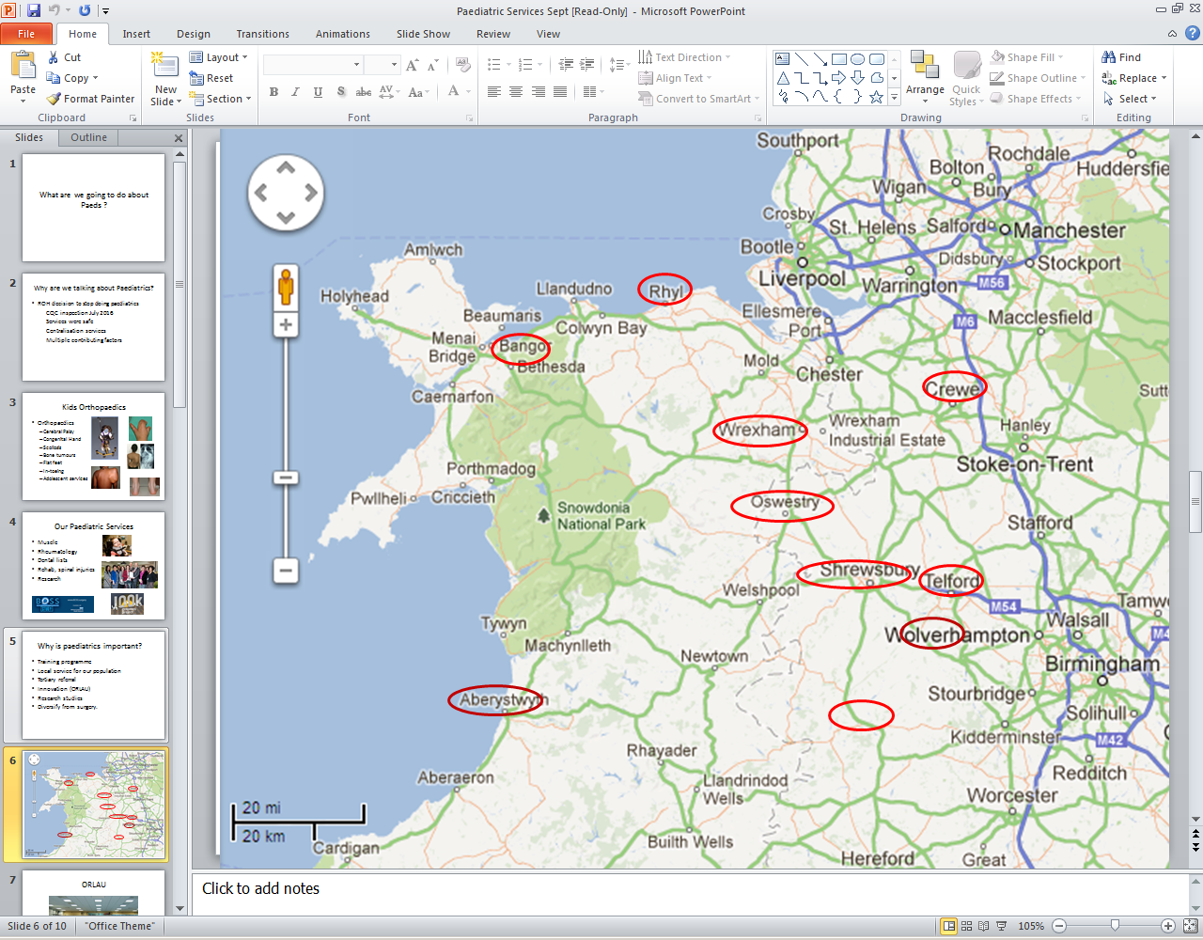

There are opportunities to build upon our organisational strengths and collaborate further with other paediatric services.

### Spinal Injuries

The Midland Centre for Spinal Injuries (MCSI) is one of 11 in the UK designated to receive and treat spinal cord injured patients. MCSI is concerned with the prevention of Spinal Injuries, maximising neurological recovery, minimising complications disability and handicap, complications following discharge and maintain health, independence and a good quality of life on an ongoing basis. This is achieved by early admission following injury as well as an "injury to grave" service. The majority of patients are admitted within 72 hours of injury. Current bed capacity and patient flow makes the timeframe of 72 hours difficult, this has partially been overcome through a newly designed outreach service, but further work is required in this area to agree our future model on the constraints of today and in the future, recognising DGH capacity constraints.

A spinal cord injury (SCI) causes paralysis, sensory impairment, a multi-system physiological impairment and malfunction, as well as psychological, social, financial, environmental and vocational effects. The multi disciplinary team provides simultaneous care and attention to the spinal cord injury and all its effects as well as full support to the patient, partner and family members until discharge. Following discharge, MCSI offers all patients a "one stop" full assessment follow up service annually, on alternate years or every third year according to the state of health, needs and time since injury.  This is in order to prevent or detect at an early stage complications that may be present without the knowledge of the patient who has sensory impairment/loss.

MCSI also offers readmission to patients for the treatment of the majority of complications that develop in the long term.  This is essential since due to the impairment, loss of sensation, the presentation (clinical symptoms and signs) is different from the conventional clinical presentation of various conditions most clinicians have learnt in medical school.

### Orthotics

Orthotics helps to treat and rehabilitate patients by providing an orthosis to aid movement, correct deformity and relieve discomfort. It is one of the largest in-house Orthotics departments in the UK. As part of our services we offer a continuing programme of maintenance, repair, reassessment and review once an orthosis has been supplied. As described within our workforce development this is an area of focus.

As a Trust we also have an orthotics manufacturing unit producing a range of custom made orthotic devices and a number of specialised complex orthoses for both in-patients and patients attending orthotic clinics. The orthoses manufactured are specific to individual patients and based around the specific anatomical structure and requirements of the patient and built to a specification/prescription generated by a clinical Orthotist.

“Off the shelf” or stock items are not generally manufactured by the unit with the exception of some simple heel lift devices and these stock items are procured by the Clinical Orthotic Department.

The service is provided to the RJAH clinical Orthotics Department, ORLAU (Orthotic Research and Locomotor Assessment Unit) and outside trusts – predominantly the North Wales Orthotic service provided by BCUHB (Betsi Cadwaladr Local Health Board). Orders are also received from Shropshire Community Podiatry service, UHNM and other West Midlands trusts.

The unit does not produce a full range of orthotic devices but is a niche market specialist supplier. In 2016/17, DOM produced 7,165 devices. There is a KPI set for 90% turnaround within two weeks – consistent with commercial companies.

The unit also provides a service adjusting, altering and repairing devices at the time of supply in clinic. This extends to commercially supplied products procured by Clinical orthotics where minor adjustments are required to ensure correct fitting. It is important to recognise the value of this service as this enables patients to have a “one stop shop” without the need for returning the device to the manufacturer and a subsequent hospital visit.

There is a growing requirement for non-surgical intervention in orthopaedics and diabetes leading to an increasing requirement for Orthotic intervention. There are also increases in requirement for complex orthoses such as KAFOs and spinal bracing following increasing evidence of the efficacy of Orthotic treatment and the desire to minimise surgical intervention. Some demand is arising from patient requirement for non-surgical intervention.

The commercial model for Orthotics is the joint provision of clinical and manufacturing services. Contracts such as these are held by nearby hospitals in the North West and Midlands such as Wirral, Chester and the Royal Orthopaedic Hospital in Birmingham. Such a service would require an arrangement where RJAH employed orthotists would provide a clinical service at remote sites. This arrangement would have the advantage of ensuring that all goods manufactured by DOM could be procured from RJAH.

The current methodologies within the industry are labour intensive and involve the orthotist taking a negative plaster cast or a foot impression of the patients limb which is then filled with plaster of paris to produce a positive copy of the limb then a negative device including the corrective elements is produced to fit the patients limb.

Technical advances are emerging within the private sector. Investment in technology is being seen as a mechanism to drive cheaper production. This involved 3D scanning of the limb and the application of corrective elements via software manipulation. The DOM unit provides a limited service in this area and business cases will be produced looking at expansion of this process.

### Orthotics Research Locomotor Assessment Unit

The service has three distinct roles;

* clinical service,
* research & development
* provision of training courses in our field of expertise.

Within these three roles the service offers movement analysis and rehabilitation engineering services for the sole benefit of NHS patients.  The routine activities include;

* Assess children and adults with mobility problems by gait analysis
* Advise patients and referring clinicians on treatment options and strategies
* Deliver orthotic and physiotherapy solutions for adults and children
* Deliver complex mobility aids and devices
* Train health professional in the fields of movement analysis and rehabilitation engineering
* Research and develop engineering solutions for mobility impairment
* Research mobility impairment by means of gait analysis

The success of the service both financially and clinically is based on a foundation of research and development from our past, but that is still embedded within the department. The focus to ensure a financially viable service has in recent times meant a greater focus on our clinical service, which has been very successful with the increased activity levels and financial position. As we move forward there will be a requirement to rebalance as research and development in this arena will secure the future service model, this will require an investment in both infrastructure and workforce time to develop.

### Sports Injuries

The sports injuries service is in the prevention and treatment of sports related health problems, irrespective of age or ability, whilst the reputation of Oswestry Sports Injury Services is grounded in the treatment it provides to professional sportspeople, those involved with sport at any level are welcome to access our NHS or private facilities.

Next steps for this service need clarifying with greater market investigation, when reviewing UCLH’s partnership with HCA in the form of a joint venture creating the Institute of Sports Exercise and Health, which focuses predominantly on the private market but has a more wider specialty base covering cardiac as well as orthopaedic.

### Bone Tumour

The Montgomery Unit treats patients with bone and soft tissue sarcomas, bone metastases, benign bone and soft tissue tumours and tumour-like conditions. As one of five bone cancer centres in the UK, we are approved and directly funded by [NHS England](https://www.england.nhs.uk/) for the treatment of primary bone sarcomas. The other centres are in London, Oxford, Birmingham and Newcastle upon Tyne.

The multi-disciplinary team for treating bone tumours and soft tissue sarcomas is made up of oncological orthopaedic surgeons, medical oncologists, radiotherapists, radiologists, pathologists, specialist nurses and therapists.

Through the infrastructure investment placed within our national bone tumour unit recently, our focus now moves to patient outcomes and the use of this data in our care model and any potential future expansion of service, whilst looking to ensure alignment with operational excellence for continuous improvement in the efficiency of our services.

### Therapies

The Therapy department is made up of specialist teams of Occupational Therapists, Physiotherapists, Support Workers and administrative staff.

There is also a [hydrotherapy pool](http://www.rjah.nhs.uk/Our-Services/Therapy/hydrotherapy.aspx) on site for In-patient and Outpatient treatment.

RJAH have established an AHP lead for the Trust, who sits within our senior leadership team and attends clinical cabinet, supporting the national movement of ‘Allied Health Professions into Action’ to;

* Understand the opportunities of the contribution of AHPs including their transformative potential and any challenges.
* To strengthen AHP leadership.

RJAH recognise our AHP workforce can support our strategic direction, particularly our MSK service aspiration, through;

* Improving the health and well-being of individuals and populations.
* Support and provide solutions to general practice to address demand.
* Support integration, addressing historical service boundaries to reduce duplication and fragmentation.
* Deliver evidence based/informed practice to address unexplained variances in service quality and efficiency.

Therefore RJAH will support our AHPs to meet the challenges of changing care needs through;

* AHPs that can lead change.
* Further developing AHPs skills.
* Support our AHPs to evaluate, improve and evidence the impact of their contribution.
* Develop AHPs to more greatly utilise information and technology.

This is in the context of between 2012 and 2017 HEE maintained broadly the level of AHP training places to support a strong growth in the number of registered AHP’s. Since the change in undergraduate funding models physiotherapy has seen a significant increase in student numbers as well as extra training places announced in 2017. However, it is recognised that certain AHP groups, the undergraduate courses are struggling to be filled such as orthotics and podiatry. RJAH have been working with Keele University in the development of both a radiographer and orthotics course.

There will be a requirement for us to review our service provision moving forwards in terms of locations and developing our estate.

### Radiology

The department provides a general radiology imaging services for hospital inpatients as well as undertaking referrals from regional GPs and allied health professions.  For patients with musculoskeletal problems, we offer specialised regional and supra-regional imaging and interventional services.

Equipped with general radiography equipment (x-ray machines), fluoroscopy units, Computer Tomography (CT), the latest 3T Magnetic Resonance Imaging scanner, Isotope scanner and two ultrasound scanners.

We offer specialist expertise in the diagnosis and treatment of musculoskeletal disorders including interventional procedures such as injections, aspirations, drainages, biopsies and imaged guided treatment procedures. This includes sports injuries and spinal disorders.

Special expertise areas:

* musculoskeletal imaging
* one of five national primary bone tumour centres
* image guided interventional procedures.
* imaging services from general radiologists, with the exception of invasive angiography.
* non-invasive angiography using CT or MR imaging

Through our capital planning work, a five year plan has been established for Radiology, further work is now required in the funding of such, investigating managed service contracts and understanding changes in the market to support such.

### Pathology

The Trust will continue to develop its collaborative partnerships within pathology to ensure the needs to our organisation are met through such arrangements.

### Pharmacy

This service carries out various offerings, covering expert advice to dispensing. In terms of items dispensed the activity levels over the last three years have remained relatively static. However as has been seen with the clinical professions, pharmacy has seen greater specialisation which has created complexities in cover to ensure that RJAH maintain the right skill mix on any given day, the development of highly specialist knowledge has come at the expense of flexibility.